TCODES:

SE11

SE37

SEGW

/IWFND/MAINT_SERVICE

Z-Tables are created in SE11 :

1. ZLFA1_MASTER - Vendor Master Table
2. ZEKKO_HEADER - Purchase Order Header Table
3. ZEKPO_ITEM - Purchase Order Item Table

Creating Project:

By using ‘SEGW’ tcode we can create our project.

Execute ‘SEGW’ tcode.

Click on ‘CREATE’ in Application Tool Bar.

Then Give Project name: ZTEST_PAVAN and Description: Test Project.

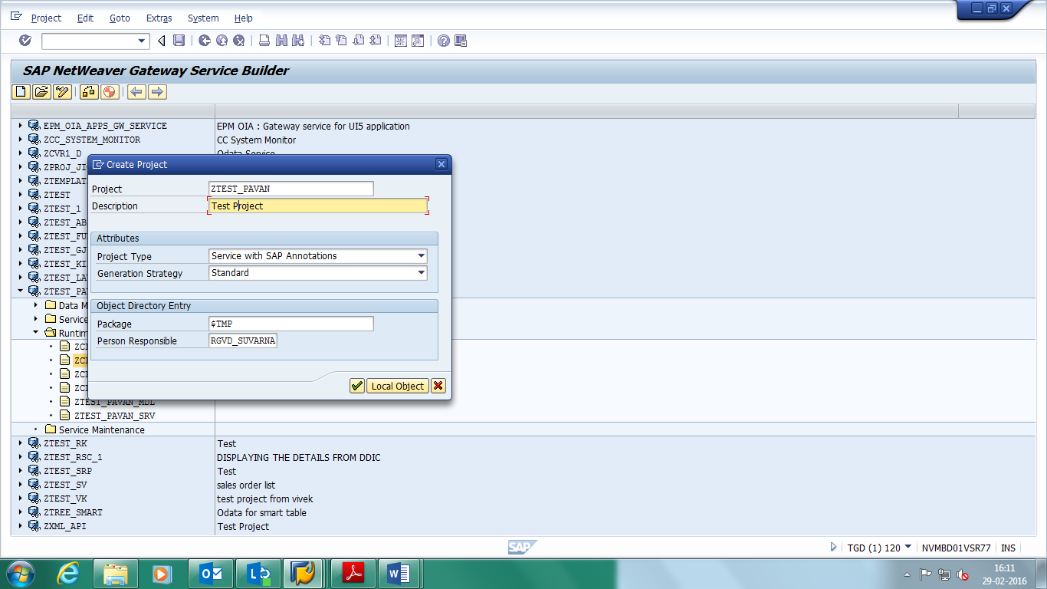

Click on Local Object.

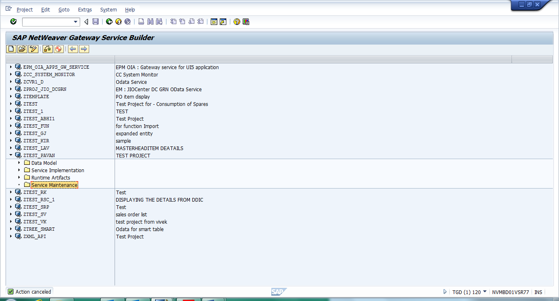

**Creating ENTITY TYPE by Using DDIC Structure:**

**Master Entity Type:-**

Expand The Project ‘ZTEST_PAVAN’.

Select The Data Model and Right Click on it -> IMPORT -> DDIC Structure.

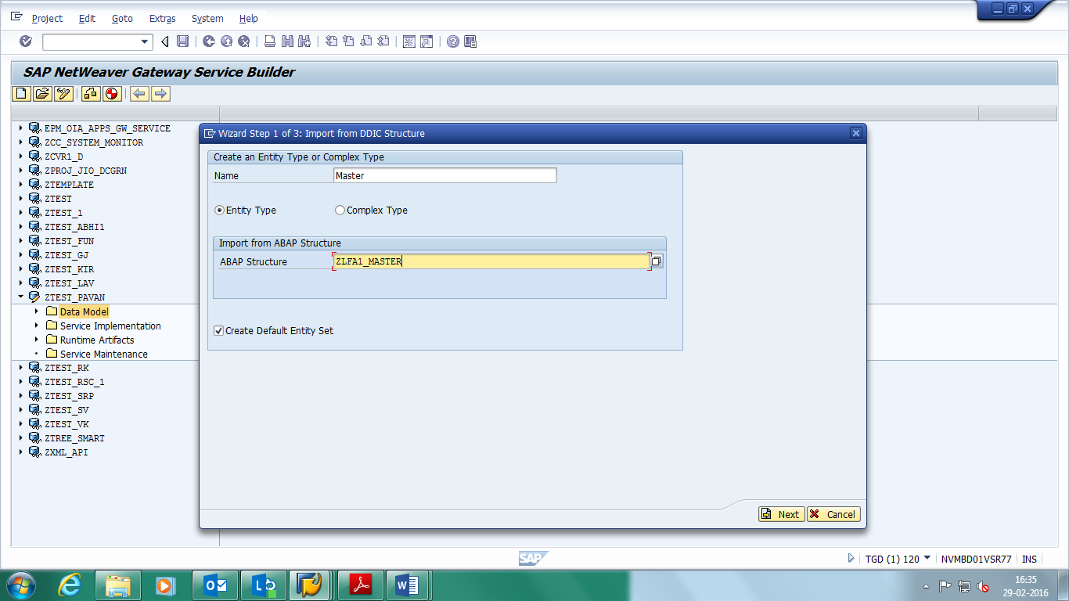Provide Entity Name: ‘Master’, ABAP Structure Name: ‘ZLFA1_MASTER’ Click on Next.

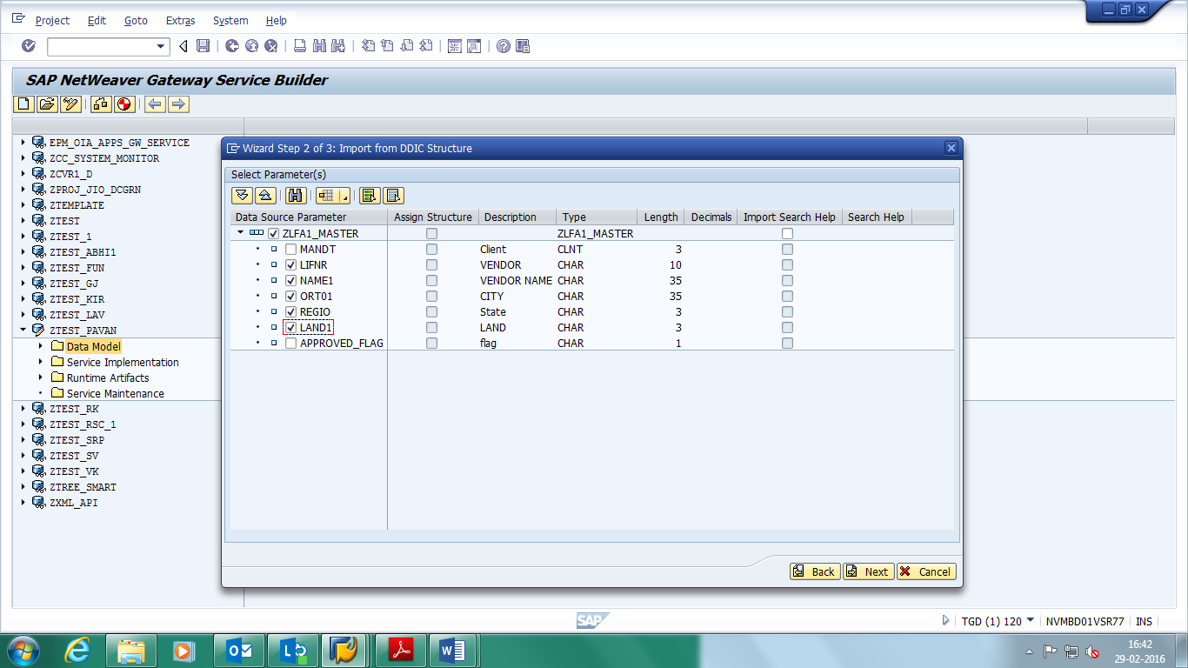Select our Required Fields and Click on Next.

Select the check Box Is Key and Click on Finish.

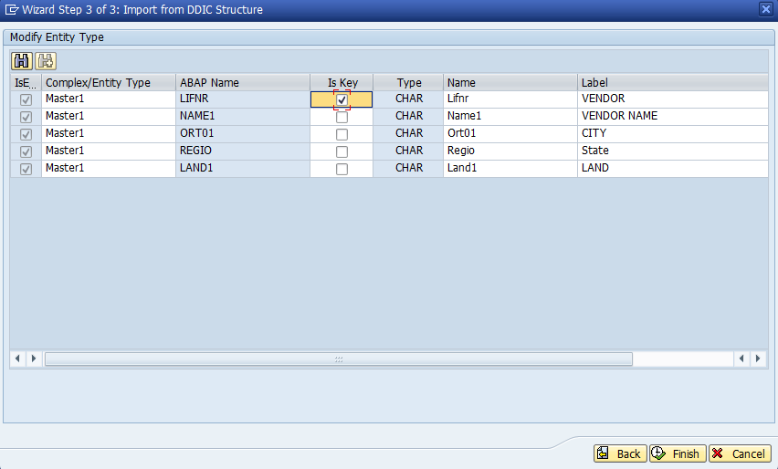

Click on Finish.

Note:- Entity Sets are Automatically Created at the Time of When We Creating Entity Types.

Save Project, Click on Check Project Consistency and Click on Generate Runtime Objects.

Then Automatically Four Classes will generate.

1. ZCL_ZTEST_PAVAN_DPC
2. ZCL_ZTEST_PAVAN_DPC_EXT
3. ZCL_ZTEST_PAVAN_MPC
4. ZCL_ZTEST_PAVAN_MPC_EXT

To Implement Methods Expand the Runtime Artifacts.

Select the ‘ZCL_ZTEST_PAVAN_DPC_EXT’ -> Right Click on it -> Go to Abap Work Bench

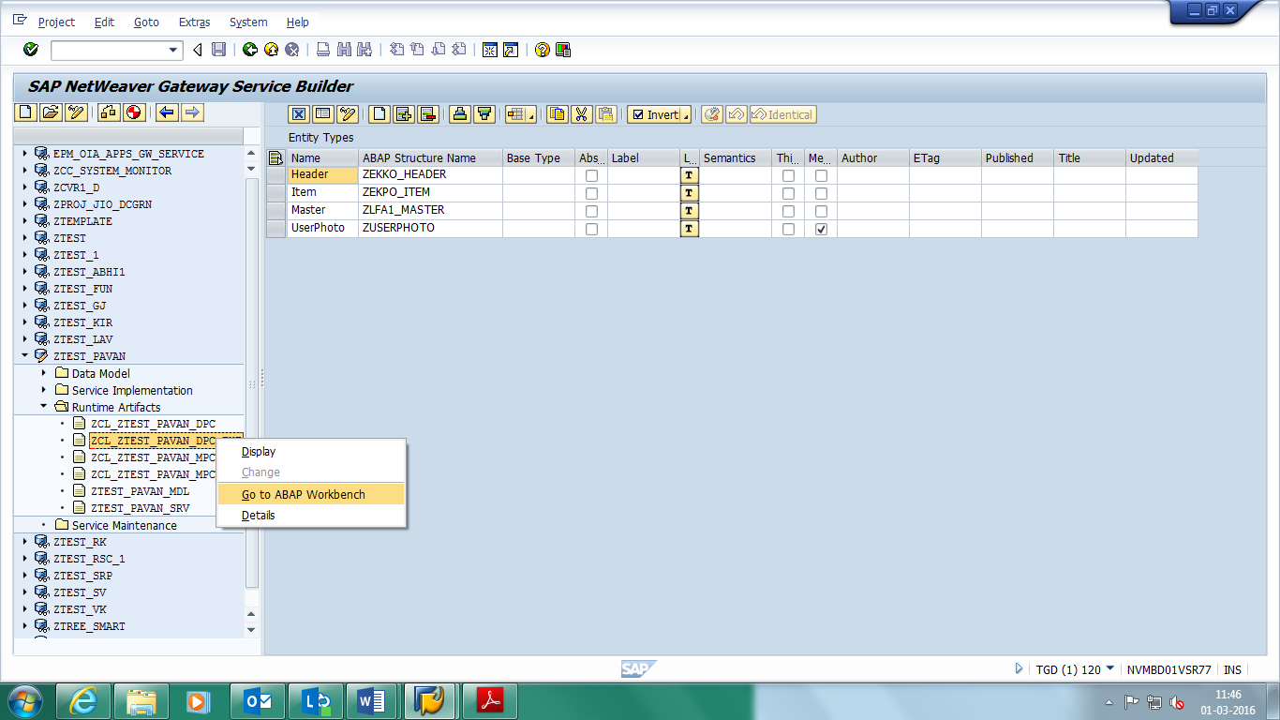

Select the Method which one we Want to Implement

-> Click on Edit Mode

-> Click on Redefine

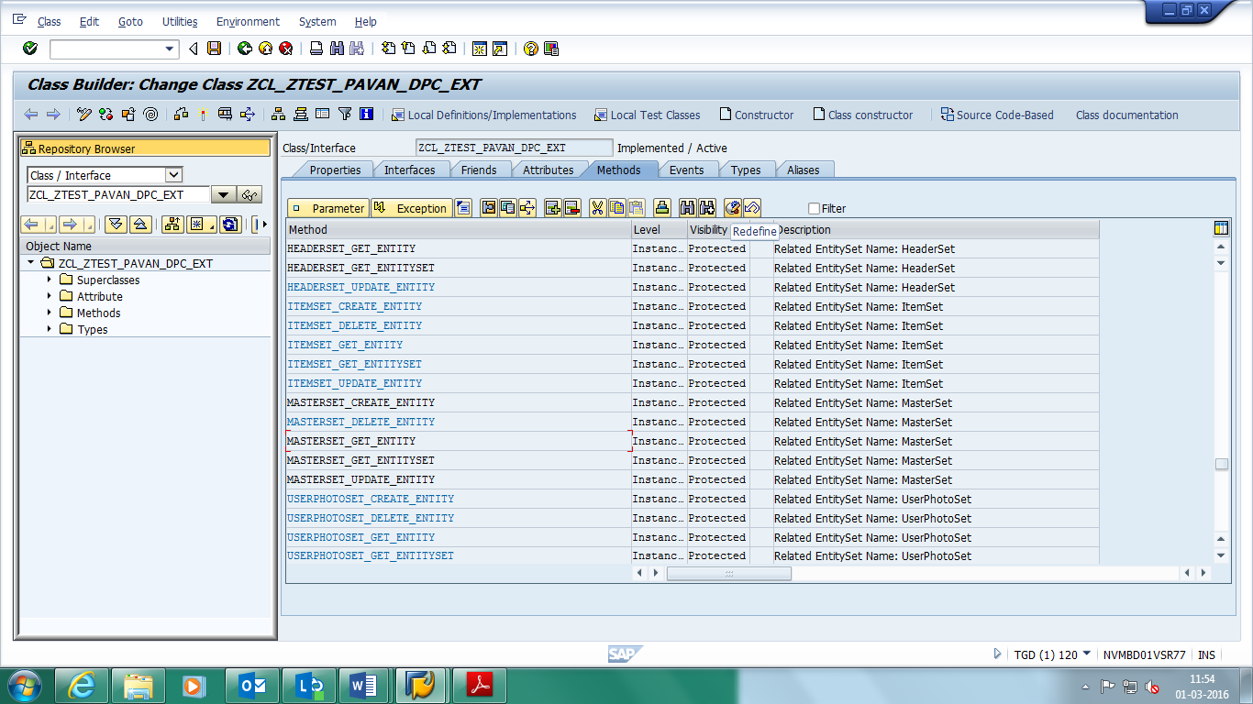

**GET_ENTITY Method:-**This is the method for the read operation for an entity / entry.

**Parameters Used in GET_ENTITY:**

**IT_KEY_TAB:** This is an Input Parameter Which Contains Two Fields Name and Value. it is Used to Represents the keys of the First Segment.

Type /IWBEP/T_MGW_NAME_VALUE_PAIR

**ER_ENTITY:** This is Output Parameter Which Returns Reference to the Application Specific Structure Which Contains the Data and it is Used to Display the Output in HTTP Response.

TYPE ZCL_ZTEST_PAVAN_MPC=>TS_MASTER

**Get_Entity Code for MASTERSET_GET_ENTITY:-**

  METHOD masterset_get_entity.  
    DATA: ls_master    TYPE zlfa1_master,  
          ls_key_tab   LIKE LINE OF it_key_tab,  
          lv_lifnr     TYPE lifnr,  
          ls_return    TYPE bapiret2,  
          lo_container TYPE REF TO /iwbep/if_message_container.  
  
    READ TABLE it_key_tab INTO ls_key_tab WITH KEY  
                               name = 'VendorAccountNumber'.  
    IF sy-subrc = 0.  
      lv_lifnr = ls_key_tab-value.  
      UNPACK lv_lifnr TO lv_lifnr.  
    ENDIF.  
  
    SELECT SINGLE * FROM zlfa1_master INTO ls_master WHERE lifnr = lv_lifnr.  
  
    IF sy-subrc EQ 0.  
  
      er_entity-lifnr = ls_master-lifnr.  
      er_entity-name1 = ls_master-name1.  
      er_entity-ort01 = ls_master-ort01.  
      er_entity-regio = ls_master-regio.  
      er_entity-land1 = ls_master-land1.  
  
    ELSE.  
  
      ls_return-type = 'E'.  
      ls_return-message = 'No Data Found'.  
  
      lo_container = me->mo_context->get_message_container( ).  
  
      CALL METHOD lo_container->add_message  
        EXPORTING  
          iv_msg_type   = ls_return-type  
          iv_msg_id     = ls_return-id  
          iv_msg_number = ls_return-number  
          iv_msg_text   = ls_return-message.  
  
      RAISE EXCEPTION TYPE /iwbep/cx_mgw_busi_exception  
        EXPORTING  
          message_container = lo_container.  
    ENDIF.  
  
  ENDMETHOD.

Save, Check and Active the Method.

Open the ‘ACTIVATE AND MAINTAIN SERVICES’ in New Session

-> Select our Service

-> Click on Load Metadata

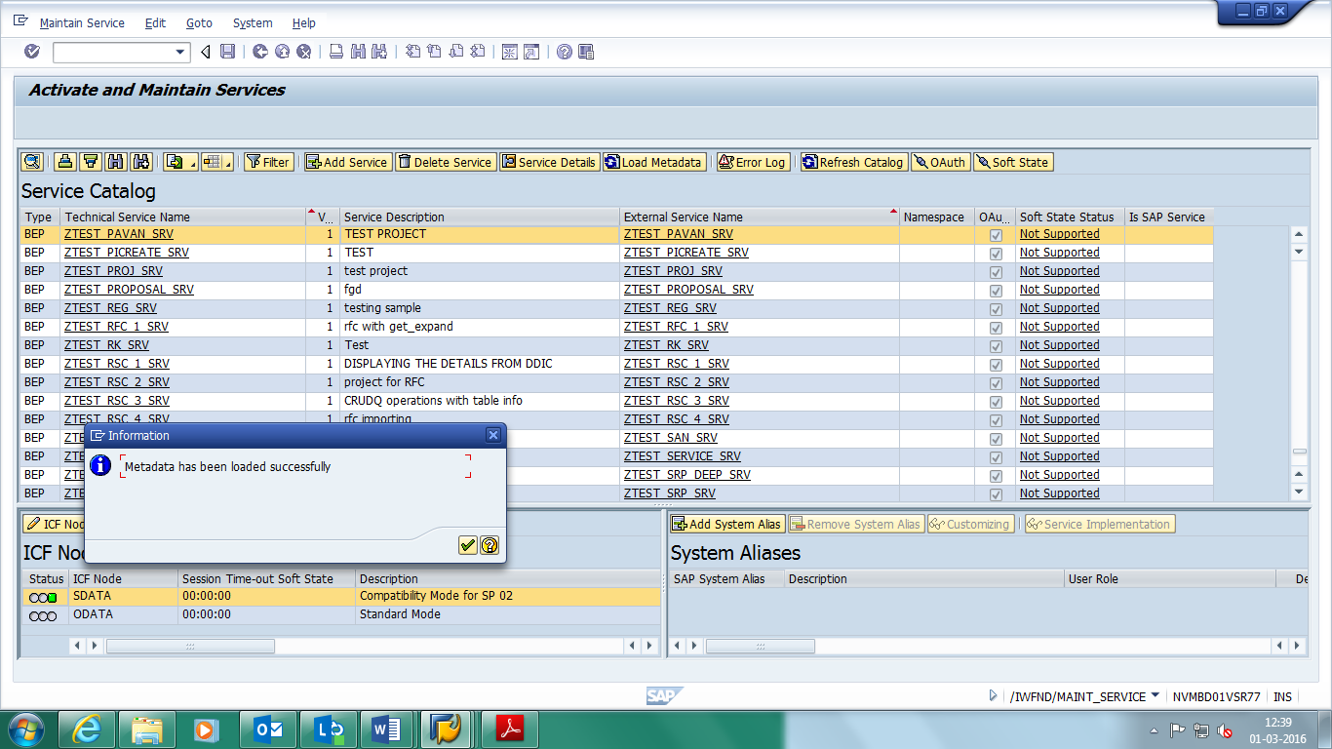

-> Click on Gateway Client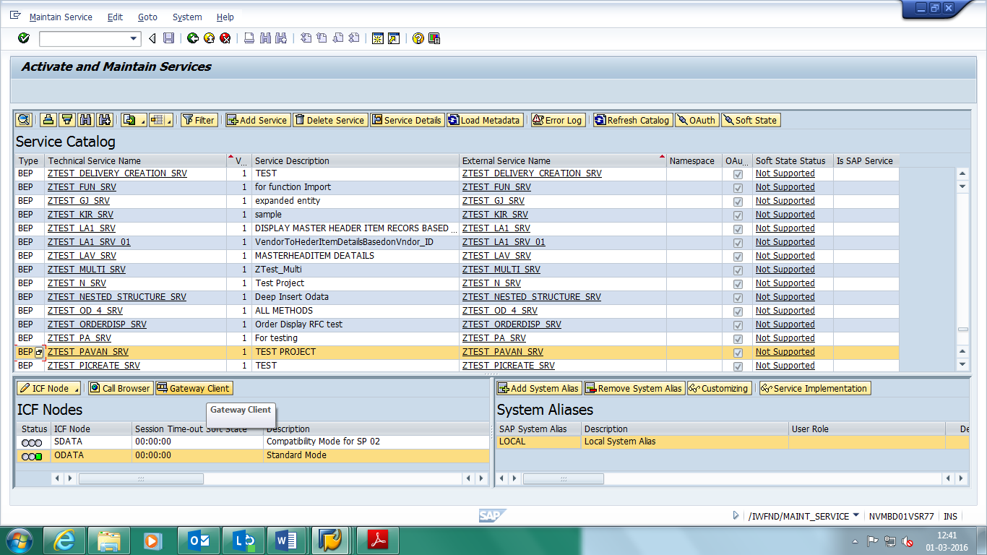

-> Click on EntitySets and Select Entityset Name

-> Select the HTTP Method ‘Get’

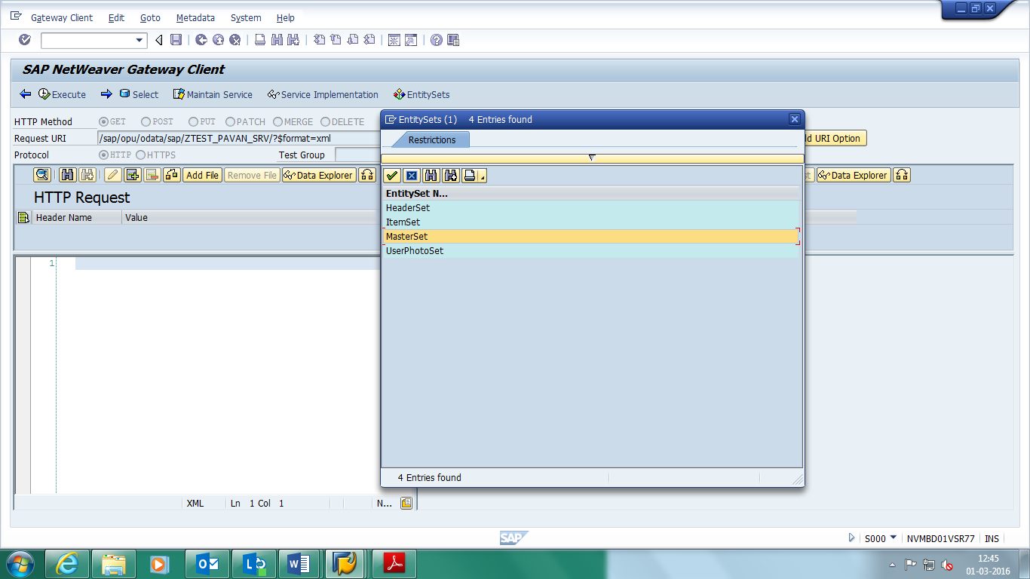

**URL:** /sap/opu/odata/sap/ZTEST_PAVAN_SRV/MasterSet('0000001002')

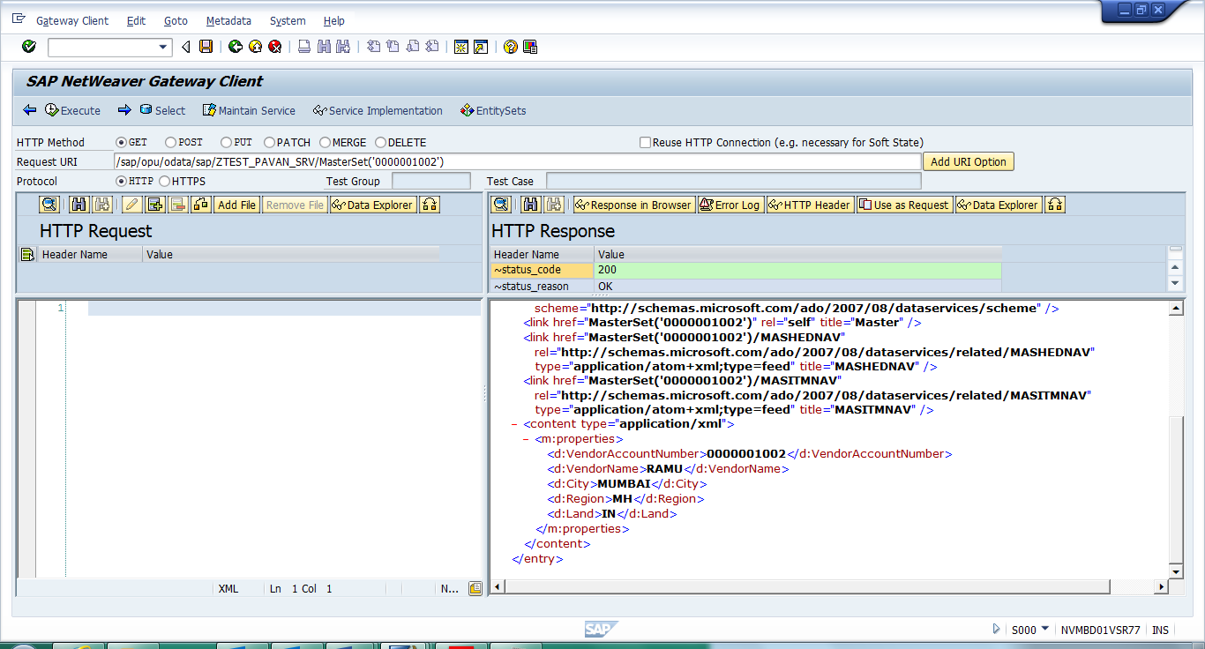

**GET_ENTITYSET Method:-** This Method Can be Used for a Read/Query Operation for an Expanded Set of Entities. This Method for a (query) Operation Returns a List of Entities and so Allows to do Filtering, Sorting, Free Text Search, etc.

**Parameters Used in GET_ENTITYSET:**

**IT_FILTER_SELECT_OPTIONS:** This is Input Parameter and Used for filter parameters as an ABAP Select-options Table for the Filter Parameter.

Type /IWBEP/T_MGW_SELECT_OPTION

**ER_ENTITYSET:** This is Output Parameter Which Returns Reference to the Application Specific Structure Which Contains the Data and it is Used to Display the Output in HTTP Response.

TYPE ZCL_ZTEST_PAVAN_MPC=>TT_MASTER

**Get_Entity Code for MASTERSET_GET_ENTITYSET:-**

method MASTERSET_GET_ENTITYSET.  
  
 DATA: LS_MASHED TYPE ZCL_ZTEST_PAVAN_MPC=>ts_master,  
          LS_LFA1   TYPE ZLFA1_MASTER,  
          LT_LFA1   TYPE STANDARD TABLE OF ZLFA1_MASTER,  
          ls_filter       TYPE /iwbep/s_mgw_select_option,  
          ls_filter_range TYPE /iwbep/s_cod_select_option,  
          lo_container type REF TO /iwbep/if_message_container,  
          ls_return type bapiret2.  
  
    LOOP AT IT_FILTER_SELECT_OPTIONS INTO ls_filter.  
  
    CASE ls_filter-property.  
      WHEN 'VendorAccountNumber'.  
    READ TABLE ls_filter-SELECT_OPTIONS INTO ls_filter_range INDEX 1.  
    IF sy-subrc = 0.  
      SELECT * FROM ZLFA1_MASTER INTO TABLE LT_LFA1 WHERE lifnr = LS_FILTER_RANGE-LOW.  
    ENDIF.  
    ENDCASE.  
    ENDLOOP.  
  
    if lt_lfa1 is NOT INITIAL.  
  
        LOOP AT LT_LFA1 INTO LS_LFA1.  
        LS_MASHED-LIFNR = LS_LFA1-LIFNR.  
        LS_MASHED-NAME1 = LS_LFA1-NAME1.  
        LS_MASHED-ORT01 = LS_LFA1-ORT01.  
        LS_MASHED-REGIO = LS_LFA1-REGIO.  
        LS_MASHED-LAND1 = LS_LFA1-LAND1.  
        APPEND LS_MASHED TO ET_ENTITYSET.  
        ENDLOOP.  
  
     else.  
  
      ls_return-type = 'E'.  
      ls_return-message = 'No Data Found'.  
  
      lo_container = me->mo_context->get_message_container( ).  
  
      CALL METHOD lo_container->add_message  
        EXPORTING  
          iv_msg_type   = ls_return-type  
          iv_msg_id     = ls_return-id  
          iv_msg_number = ls_return-number  
          iv_msg_text   = ls_return-message.  
  
      RAISE EXCEPTION TYPE /iwbep/cx_mgw_busi_exception  
        EXPORTING  
          message_container = lo_container.  
    ENDIF.  
  
  endmethod.

Save, Check and Active the Method.

Open the ‘ACTIVATE AND MAINTAIN SERVICES’ in New Session

-> Select our Service

-> Click on Load Metadata

-> Click on Gateway Client

-> Click on EntitySets and Select Entityset Name

-> Select the HTTP Method ‘Get’

-> Write the Payload in HTTP Request

**URL:**/sap/opu/odata/sap/ZTEST_PAVAN_SRV/MasterSet?$filter=VendorAccountNumber eq '0000001000'

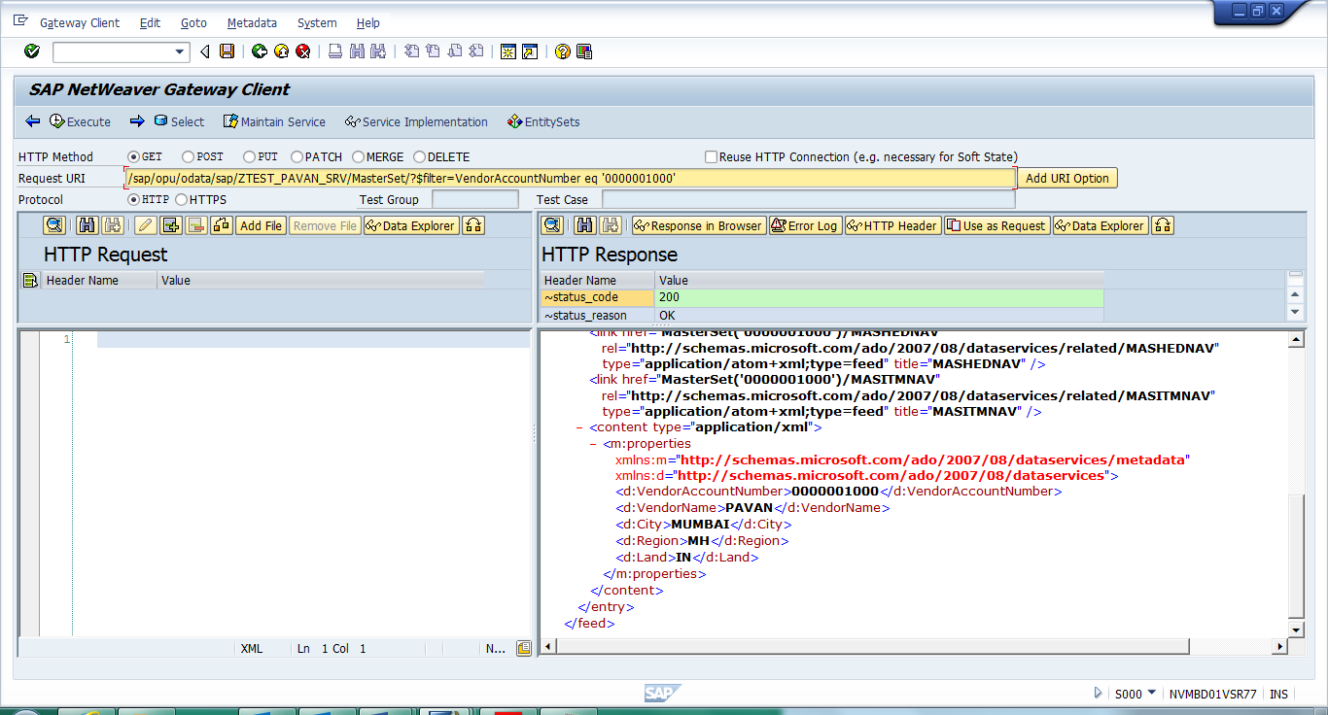

**CREATE_ENTITY Method:-**This is the method for the Create operation for an entity / entry.

**Parameters Used in CREATE_ENTITY:**

**IO_DATA_PROVIDER:** The interface to deserialize the payload into the application specific structure.

Type /IWBEP/IF_MGW_ENTRY_PROVIDER

**ER_ENTITY:** This is Output Parameter Which Returns Reference to the Application Specific Structure Which Contains the Data and it is Used to Display the Output in HTTP Response.

TYPE ZCL_ZTEST_PAVAN_MPC=>TS_MASTER

**Create_Entity Code for MASTERSET_CREATE_ENTITY:-**

method MASTERSET_CREATE_ENTITY.  
  
  
    DATA: ls_master    TYPE zcl_ztest_pavan_mpc=>ts_master,  
          ls_lfa1      TYPE zlfa1_master,  
          ls_return    TYPE bapiret2,  
          lt_return    TYPE bapiret2_t,  
          lo_container TYPE REF TO /iwbep/if_message_container,  
          lw_lheader   TYPE ihttpnvp,  
          json         TYPE string,  
          lo_message   TYPE REF TO zcl_fiori_format_message_json.  
  
  
    io_data_provider->read_entry_data( IMPORTING es_data = ls_master ).  
  
    ls_lfa1-lifnr = ls_master-lifnr.  
    ls_lfa1-name1 = ls_master-name1.  
    ls_lfa1-ort01 = ls_master-ort01.  
    ls_lfa1-regio = ls_master-regio.  
    ls_lfa1-land1 = ls_master-land1.  
  
    INSERT zlfa1_master FROM ls_lfa1.  
    IF sy-subrc EQ 0.  
      COMMIT WORK.  
  
      ls_return-type = 'S'.  
      ls_return-message = 'Data Updated Successfully'.  
      APPEND ls_return TO lt_return.  
  
      CREATE OBJECT lo_message.  
      CALL METHOD lo_message->message_format  
        EXPORTING  
          im_returnmsg = lt_return  
        IMPORTING  
          ex_json      = json.  
  
      lw_lheader-name = 'sap-message'.  
      lw_lheader-value = json.  
      set_header( is_header = lw_lheader ).  
  
    ELSE.  
      ls_return-type = 'E'.  
      ls_return-message = 'Error in updating data '.  
  
      lo_container = me->mo_context->get_message_container( ).  
  
      CALL METHOD lo_container->add_message  
        EXPORTING  
          iv_msg_type   = ls_return-type  
          iv_msg_id     = ls_return-id  
          iv_msg_number = ls_return-number  
          iv_msg_text   = ls_return-message.  
  
      RAISE EXCEPTION TYPE /iwbep/cx_mgw_busi_exception  
        EXPORTING  
          message_container = lo_container.  
    ENDIF.  
  
    er_entity = ls_master.  
  endmethod.

Save, Check and Active the Method.

Open the ‘ACTIVATE AND MAINTAIN SERVICES’ in New Session

-> Select our Service

-> Click on Load Metadata

-> Click on Gateway Client

-> Click on EntitySets and Select Entityset Name

-> Select the HTTP Method ‘Post’

-> Write the Payload in HTTP Request

**URL:** /sap/opu/odata/sap/ZTEST_PAVAN_SRV/MasterSet

**Payload:**

<?xml version="1.0" encoding="UTF-8"?>  
<atom:entry xmlns:atom ="http://www.w3.org/2005/Atom"  
xml:base="http://nvmbd01vsr77.bss.dev.jio.com:8000/sap/opu/odata/sap/ZTEST_PAVAN_SRV/"  
xmlns:m="http://schemas.microsoft.com/ado/2007/08/dataservices/metadata"  
xmlns:d="http://schemas.microsoft.com/ado/2007/08/dataservices">  
 <atom:content type="application/xml">  
  <m:properties>  
   <d:VendorAccountNumber>0000001004</d:VendorAccountNumber>  
   <d:VendorName>MANESH</d:VendorName>  
   <d:City>MUM</d:City>  
   <d:State>MP</d:State>  
   <d:Country>IN</d:Country>  
  </m:properties>  
  </atom:content>  
  </atom:entry>

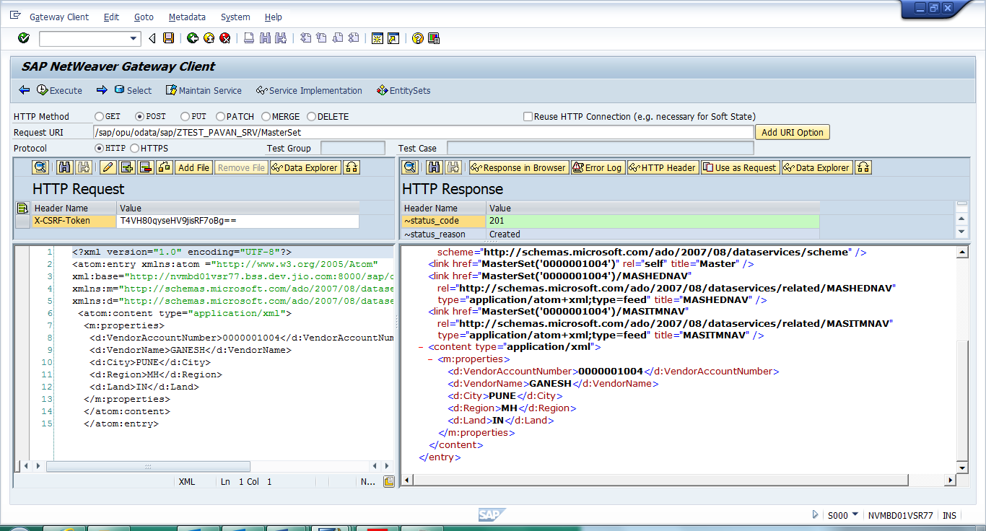

**UPDATE_ENTITY Method:-**This is the method for the Update operation for an entity / entry.

**Parameters Used in UPDATE_ENTITY:**

**IO_DATA_PROVIDER:** The interface to deserialize the payload into the application specific structure.

Type /IWBEP/IF_MGW_ENTRY_PROVIDER

**IT_KEY_TAB:** This is an Input Parameter Which Contains Two Fields Name and Value. it is Used to Represents the keys of the First Segment.

Type /IWBEP/T_MGW_NAME_VALUE_PAIR

**Update_Entity Code for MASTERSET_UPDATE_ENTITY:-**

  METHOD masterset_update_entity.  
    DATA: ls_master    TYPE zcl_ztest_pavan_mpc=>ts_master,  
          ls_lfa1      TYPE zlfa1_master,  
          ls_return    TYPE bapiret2,  
          lt_return    TYPE bapiret2_t,  
          lv_lifnr     TYPE lifnr,  
          lv_varkey    TYPE vim_enqkey,  
          ls_key_tab   TYPE /iwbep/s_mgw_name_value_pair,  
          lo_container TYPE REF TO /iwbep/if_message_container,  
          lw_lheader   TYPE ihttpnvp,  
          json         TYPE string,  
          lo_message   TYPE REF TO zcl_fiori_format_message_json.  
  
  
    io_data_provider->read_entry_data( IMPORTING es_data = ls_master ).  
  
    READ TABLE it_key_tab INTO ls_key_tab WITH KEY  
                               name = 'VendorAccountNumber'.  
    IF sy-subrc = 0.  
      lv_lifnr = ls_key_tab-value.  
    ENDIF.  
  
    SELECT SINGLE * FROM zlfa1_master INTO ls_lfa1 WHERE lifnr = lv_lifnr.  
    IF sy-subrc EQ 0.  
  
      ls_lfa1-name1 = ls_master-name1.  
      ls_lfa1-ort01 = ls_master-ort01.  
      ls_lfa1-regio = ls_master-regio.  
      ls_lfa1-land1 = ls_master-land1.  
  
      CONCATENATE sy-mandt lv_lifnr INTO lv_varkey.  
  
      CALL FUNCTION 'ENQUEUE_E_TABLE'  
        EXPORTING  
          mode_rstable = 'E'  
          tabname      = 'ZLFA1_MASTER'  
          varkey       = lv_varkey  
          _scope       = '3'.  
  
  
      UPDATE zlfa1_master FROM ls_lfa1.  
      IF sy-subrc EQ 0.  
        COMMIT WORK.  
  
        ls_return-type = 'S'.  
        ls_return-message = 'Data Updated Successfully'.  
        APPEND ls_return TO lt_return.  
  
        CREATE OBJECT lo_message.  
        CALL METHOD lo_message->message_format  
          EXPORTING  
            im_returnmsg = lt_return  
          IMPORTING  
            ex_json      = json.  
  
        lw_lheader-name = 'sap-message'.  
        lw_lheader-value = json.  
        set_header( is_header = lw_lheader ).  
  
      ELSE.  
        ls_return-type = 'E'.  
        ls_return-message = 'Error in updating data '.  
  
        lo_container = me->mo_context->get_message_container( ).  
  
        CALL METHOD lo_container->add_message  
          EXPORTING  
            iv_msg_type   = ls_return-type  
            iv_msg_id     = ls_return-id  
            iv_msg_number = ls_return-number  
            iv_msg_text   = ls_return-message.  
  
        RAISE EXCEPTION TYPE /iwbep/cx_mgw_busi_exception  
          EXPORTING  
            message_container = lo_container.  
      ENDIF.  
  
        CALL FUNCTION 'DEQUEUE_E_TABLE'  
          EXPORTING  
            mode_rstable = 'E'  
            tabname      = 'ZLFA1_MASTER'  
            varkey       = lv_varkey  
            _scope       = '3'.  
  
    ELSE.  
      ls_return-type = 'E'.  
      ls_return-message = 'Invalid Vendor Num'.  
  
      lo_container = me->mo_context->get_message_container( ).  
  
      CALL METHOD lo_container->add_message  
        EXPORTING  
          iv_msg_type   = ls_return-type  
          iv_msg_id     = ls_return-id  
          iv_msg_number = ls_return-number  
          iv_msg_text   = ls_return-message.  
  
      RAISE EXCEPTION TYPE /iwbep/cx_mgw_busi_exception  
        EXPORTING  
          message_container = lo_container.  
    ENDIF.  
  
  ENDMETHOD.

Save, Check and Active the Method.

Open the ‘ACTIVATE AND MAINTAIN SERVICES’ in New Session

-> Select our Service

-> Click on Load Metadata

-> Click on Gateway Client

-> Click on EntitySets and Select Entityset Name

-> Select the HTTP Method ‘Put’

-> Write the Payload in HTTP Request

**URL:**

/sap/opu/odata/sap/ZTEST_PAVAN_SRV/MasterSet(VendorAccountNumber='0000001004')

**Payload:**

<?xml version="1.0" encoding="UTF-8"?>  
<atom:entry xmlns:atom ="http://www.w3.org/2005/Atom"  
xml:base="http://nvmbd01vsr77.bss.dev.jio.com:8000/sap/opu/odata/sap/ZTEST_PAVAN_SRV/"  
xmlns:m="http://schemas.microsoft.com/ado/2007/08/dataservices/metadata"  
xmlns:d="http://schemas.microsoft.com/ado/2007/08/dataservices">  
 <atom:content type="application/xml">  
  <m:properties>  
   <d:VendorAccountNumber>0000001004</d:VendorAccountNumber>  
   <d:VendorName>MANESH</d:VendorName>  
   <d:City>MUM</d:City>  
   <d:State>MP</d:State>  
   <d:Country>IN</d:Country>  
  </m:properties>  
  </atom:content>  
  </atom:entry>

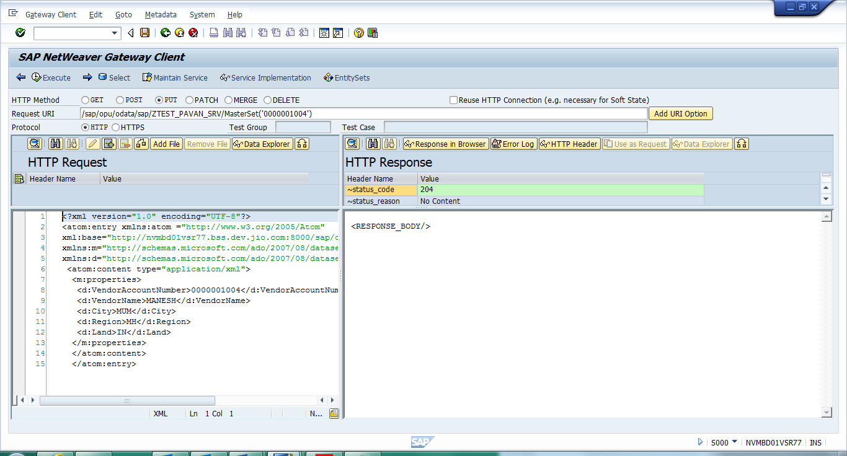

**DELETE_ENTITY Method:-**This is the method for the Update operation for an entity / entry.

**Parameters Used in DELETE_ENTITY:**

**IT_KEY_TAB:** This is an Input Parameter Which Contains Two Fields Name and Value. it is Used to Represents the keys of the First Segment.

Type /IWBEP/T_MGW_NAME_VALUE_PAIR

  method MASTERSET_DELETE_ENTITY.  
    DATA: ls_master    TYPE zcl_ztest_pavan_mpc=>ts_master,  
          ls_lfa1      TYPE zlfa1_master,  
          ls_return    TYPE bapiret2,  
          lt_return    TYPE bapiret2_t,  
          lv_lifnr     TYPE lifnr,  
          ls_key_tab   TYPE /iwbep/s_mgw_name_value_pair,  
          lo_container TYPE REF TO /iwbep/if_message_container,  
          lw_lheader   TYPE ihttpnvp,  
          json         TYPE string,  
          lo_message   TYPE REF TO zcl_fiori_format_message_json.  
  
  
    READ TABLE it_key_tab INTO ls_key_tab WITH KEY  
                               name = 'VendorAccountNumber'.  
    IF sy-subrc = 0.  
      lv_lifnr = ls_key_tab-value.  
    ENDIF.  
  
       DELETE FROM zlfa1_master WHERE lifnr = lv_lifnr.  
      IF sy-subrc EQ 0.  
        COMMIT WORK.  
        ls_return-type = 'S'.  
        ls_return-message = 'Data Deleted Successfully'.  
        APPEND ls_return TO lt_return.  
  
        CREATE OBJECT lo_message.  
        CALL METHOD lo_message->message_format  
          EXPORTING  
            im_returnmsg = lt_return  
          IMPORTING  
            ex_json      = json.  
  
        lw_lheader-name = 'sap-message'.  
        lw_lheader-value = json.  
        set_header( is_header = lw_lheader ).  
  
      ELSE.  
        ls_return-type = 'E'.  
        ls_return-message = 'Error in deleting data '.  
  
        lo_container = me->mo_context->get_message_container( ).  
  
        CALL METHOD lo_container->add_message  
          EXPORTING  
            iv_msg_type   = ls_return-type  
            iv_msg_id     = ls_return-id  
            iv_msg_number = ls_return-number  
            iv_msg_text   = ls_return-message.  
  
        RAISE EXCEPTION TYPE /iwbep/cx_mgw_busi_exception  
          EXPORTING  
            message_container = lo_container.  
      ENDIF.  
  
  endmethod.

Save, Check and Active the Method.

Open the ‘ACTIVATE AND MAINTAIN SERVICES’ in New Session

-> Select our Service

-> Click on Load Metadata

-> Click on Gateway Client

-> Click on EntitySets and Select Entityset Name

-> Select the HTTP Method ‘Delete’

-> Write the Payload in HTTP Request

**URL:**

/sap/opu/odata/sap/ZTEST_PAVAN_SRV/MasterSet(VendorAccountNumber='0000001004')

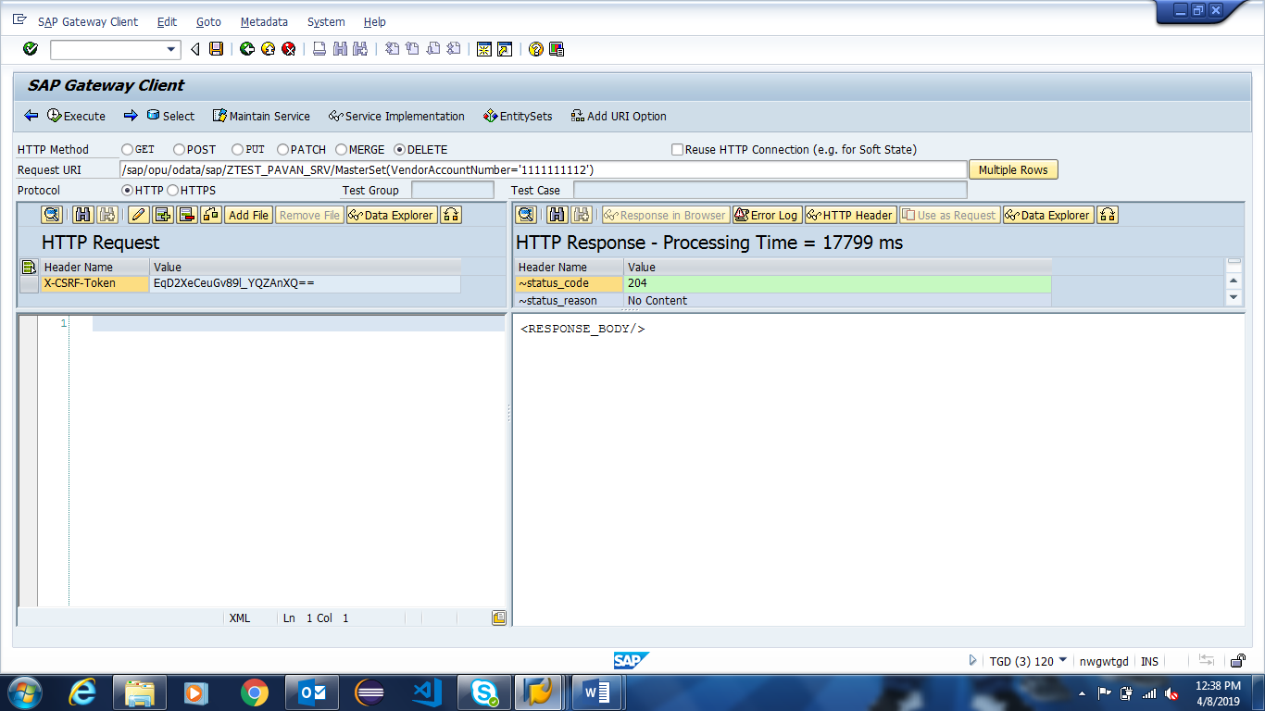

**Header Entity Type:-**

Expand The Project ‘ZTEST_PAVAN’.

Select The Data Model and Right Click on it -> IMPORT -> DDIC Structure.

Provide Entity Name: ‘Header’, ABAP Structure Name: ‘ZEKKO_HEADER’ Click on Next.

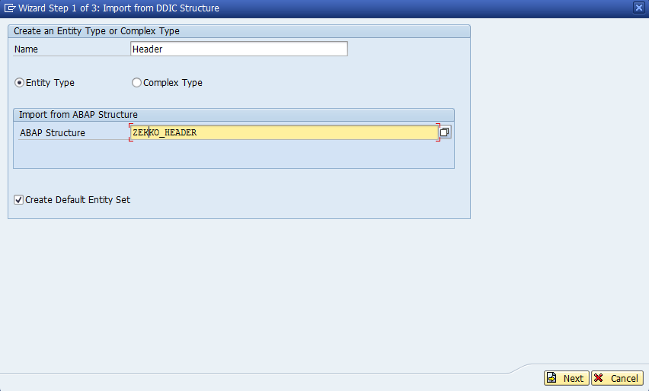

Select our Required Fields and Click on Next.

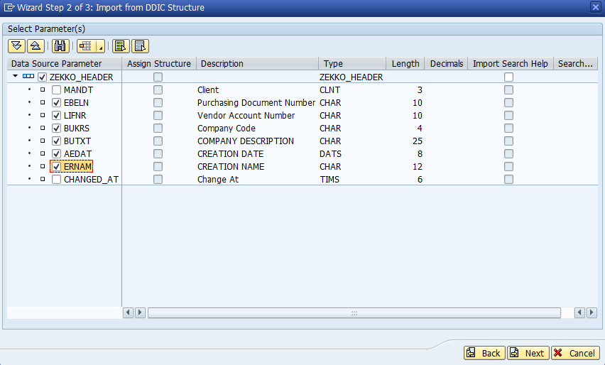

Select the check Box Is Key and Click on Finish.

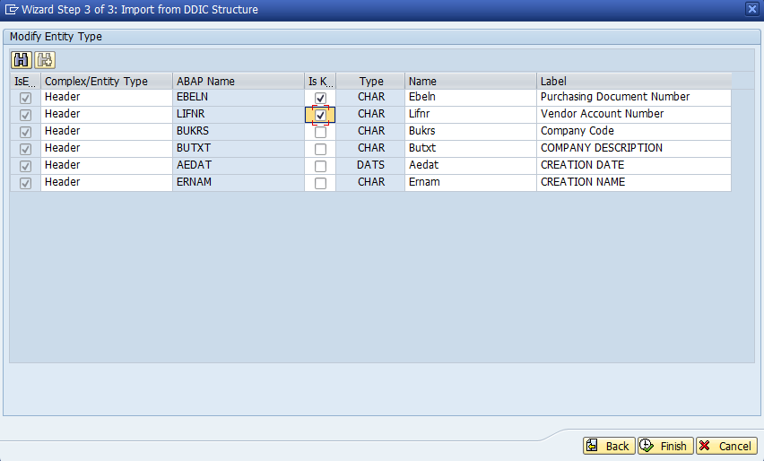

**Item Entity Type:-**

Expand The Project ‘ZTEST_PAVAN’.

Select The Data Model and Right Click on it -> IMPORT -> DDIC Structure.

Provide Entity Name: ‘Item’, ABAP Structure Name: ‘ZEKPO_ITEM’ Click on Next.

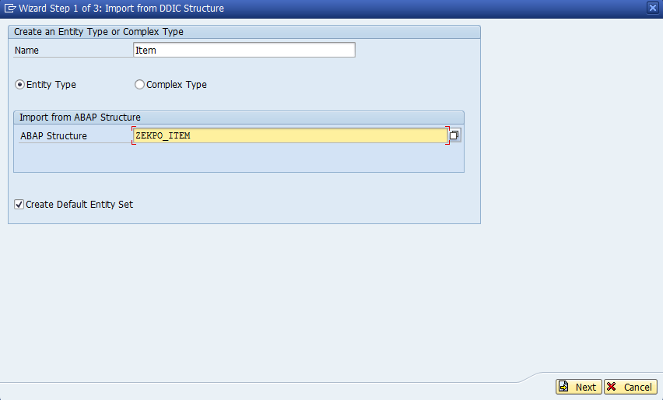

Select our Required Fields and Click on Next.

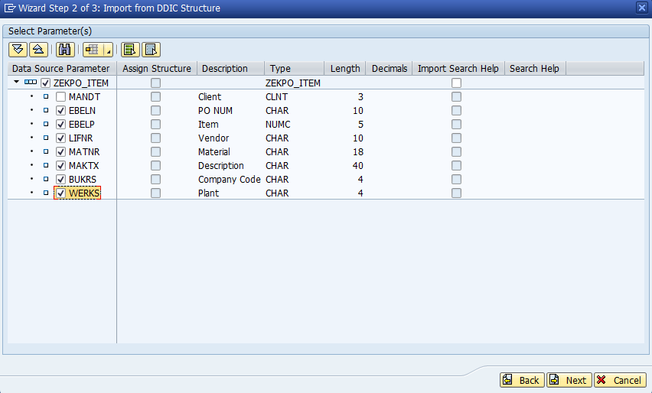

Select the check Box Is Key and Click on Finish.

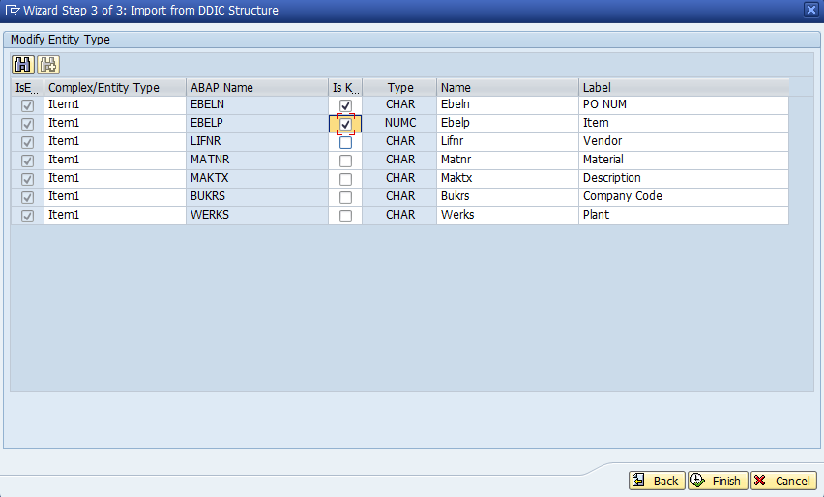

**Creating ASSOCIATIONS:-**

**MASTHEAD Association:**

Expand The Project ‘ZTEST_PAVAN’.

Expand The Project ‘Data Model’.

Select The Associations and Right Click on it -> Create.

Provide Association Name: ‘MASTHEAD’, Principal Entity Name: ‘Master’, Dependent Entity Name: ‘Header’, Navigation Name: ‘MASTHEADNAV’ and Click on Next.

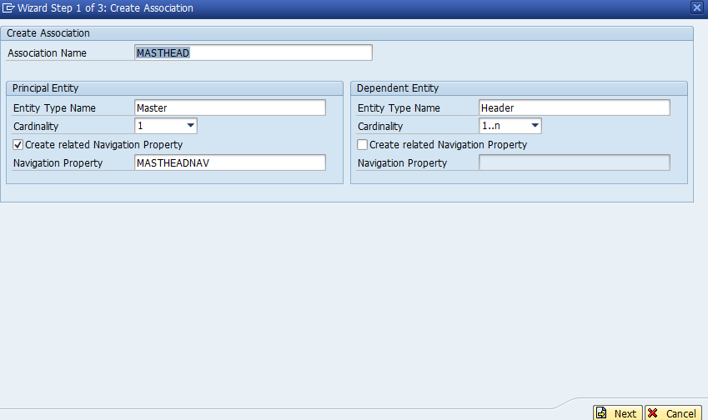

Give The Dependent Property ‘VendorNum’.

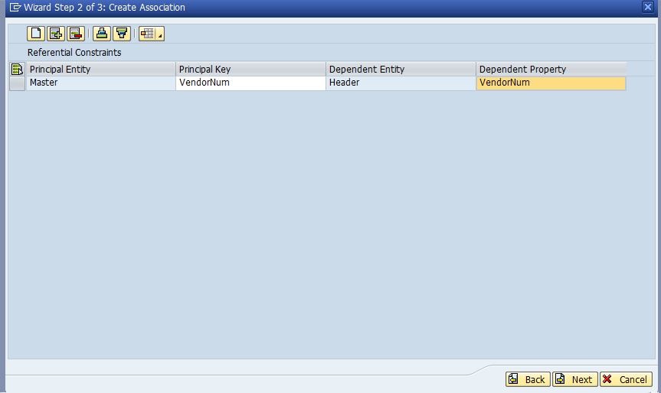

Click on Next.

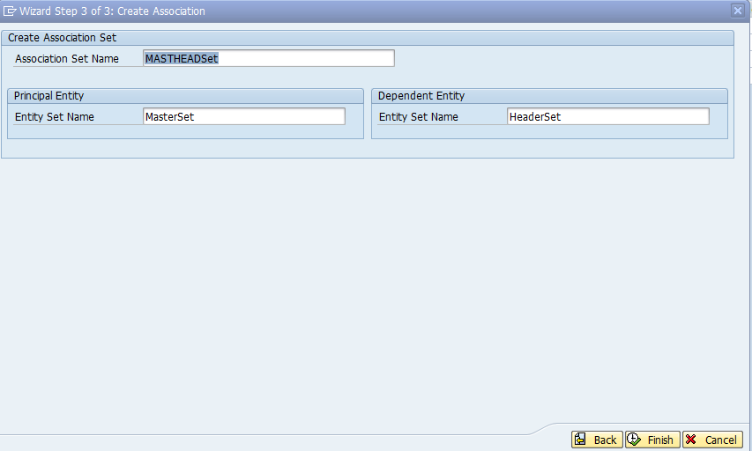

Click on Finish.

**HEADITEM Association:**

Expand The Project ‘ZTEST_PAVAN’.

Expand The Project ‘Data Model’.

Select The Associations and Right Click on it -> Create.

Provide Association Name: ‘HEADITEM’, Principal Entity Name: ‘Header’, Dependent Entity Name: ‘Item’, Navigation Name: ‘HEADITEMNAV’ and Click on Next.

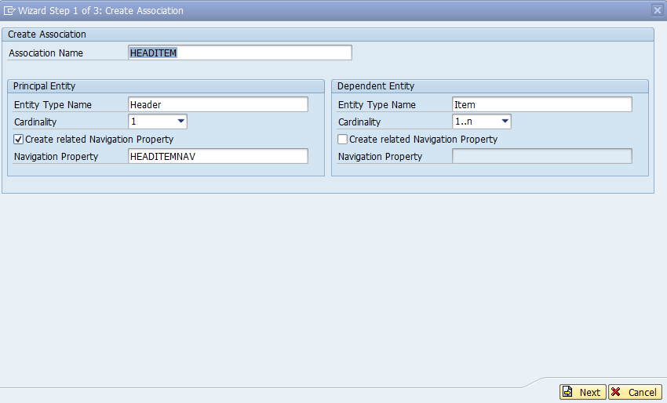

Give The Dependent Property ‘OrderNum’.

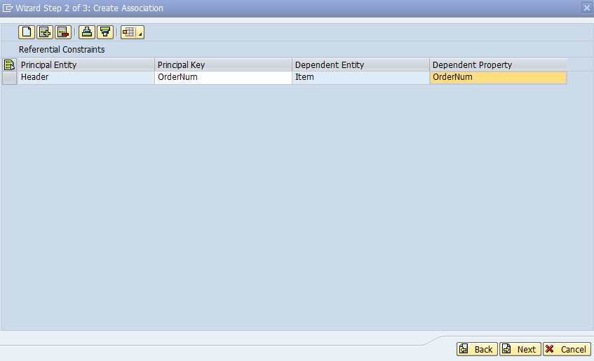

Click on Next.

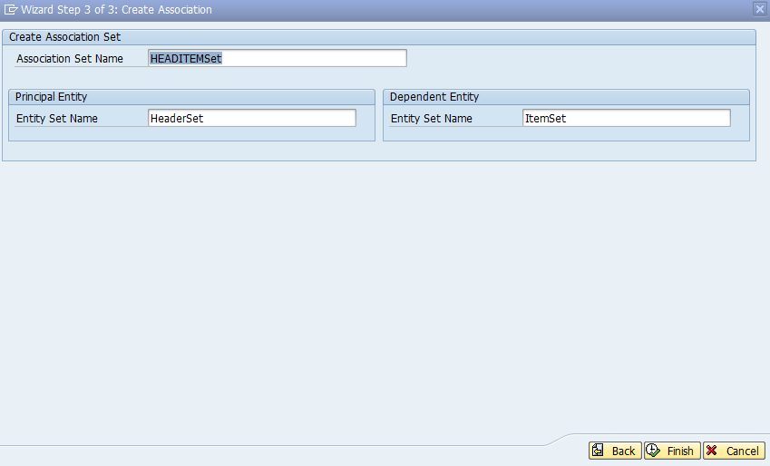

Click on Finish.

Note:- Entity Sets and Association Sets are Automatically Created at the Time of When We Creating Entity Types and Associations.

**CREATE_DEEP_ENTITY Method:**

**Parameters Used in CREATE_DEEP_ENTITY:**

**ER_DEEP_ENTITY:** The returned reference to the application specific structure which contains the data.

**IO_DATA_PROVIDER:** The interface to deserialize the payload into the application specific structure. Type /IWBEP/IF_MGW_ENTRY_PROVIDER

**CREATE_DEEP_ENTITY Code:**

    METHOD /iwbep/if_mgw_appl_srv_runtime~create_deep_entity.  
  
    TYPES: BEGIN OF ty_heditm.  
            INCLUDE TYPE zcl_ztest_pavan_mpc=>ts_header.  
    TYPES: headitemnav TYPE STANDARD TABLE OF zcl_ztest_pavan_mpc=>ts_item WITH NON-UNIQUE DEFAULT KEY,  
           END OF ty_heditm.  
  
  
    TYPES: BEGIN OF ty_mashed.  
            INCLUDE TYPE zcl_ztest_pavan_mpc=>ts_master.  
    TYPES: mastheadnav TYPE STANDARD TABLE OF ty_heditm WITH NON-UNIQUE DEFAULT KEY,  
           END OF ty_mashed.  
  
    DATA: wa_mashed TYPE ty_mashed,  
          wa_lfa1   TYPE zlfa1_master,  
          wa_ekko   TYPE zekko_header,  
          wa_ekpo   TYPE zekpo_item,  
          it_ekko   TYPE TABLE OF zekko_header,  
          it_ekpo   TYPE TABLE OF zekpo_item,  
          wa_head   TYPE ty_heditm,  
          wa_item   TYPE zcl_ztest_pavan_mpc=>ts_item.  
  
      DATA   :   lv_flag    TYPE abap_bool VALUE space,  
             lw_lheader TYPE ihttpnvp,  
             json       TYPE string,  
             lo_message TYPE REF TO zcl_fiori_format_message_json.  
  
  CONSTANTS: lc_e TYPE char01 VALUE 'E',  
             lc_w TYPE char01 VALUE 'W',  
             lc_i TYPE char01 VALUE 'I',  
             lc_s TYPE char01 VALUE 'S'.  
  
  DATA    :  lt_return    TYPE STANDARD TABLE OF bapiret2,  
             lw_return    TYPE bapiret2,  
             lo_container TYPE REF TO /iwbep/if_message_container.  
  
    io_data_provider->read_entry_data( IMPORTING es_data = wa_mashed ).  
  
    IF  wa_mashed IS NOT INITIAL.  
      wa_lfa1-lifnr = wa_mashed-lifnr.  
      wa_lfa1-name1 = wa_mashed-name1.  
      wa_lfa1-ort01 = wa_mashed-ort01.  
      wa_lfa1-regio = wa_mashed-regio.  
      wa_lfa1-land1 = wa_mashed-land1.  
  
      LOOP AT wa_mashed-mastheadnav INTO wa_head.  
        wa_ekko-ebeln = wa_head-ebeln.  
        wa_ekko-lifnr = wa_head-lifnr.  
        wa_ekko-bukrs = wa_head-bukrs.  
        wa_ekko-butxt = wa_head-butxt.  
        wa_ekko-aedat = wa_head-aedat.  
        wa_ekko-ernam = wa_head-ernam.  
  
        LOOP AT wa_head-headitemnav INTO wa_item.  
          wa_ekpo-ebeln = wa_item-ebeln.  
          wa_ekpo-ebelp = wa_item-ebelp.  
          wa_ekpo-matnr = wa_item-matnr.  
          wa_ekpo-maktx = wa_item-maktx.  
          wa_ekpo-bukrs = wa_head-bukrs.  
          wa_ekpo-werks = wa_item-werks.  
          APPEND wa_ekpo TO it_ekpo.  
          CLEAR: wa_ekpo, wa_item.  
        ENDLOOP.  
  
        APPEND wa_ekko TO it_ekko.  
        CLEAR: wa_ekko, wa_head.  
      ENDLOOP.  
    ENDIF.  
  
    INSERT zlfa1_master FROM wa_lfa1.  
    IF sy-subrc EQ 0.  
  
      COMMIT WORK.  
      lw_return-type = 'S'.  
      lw_return-message = 'Data Updated Successfully in Master Table'.  
      APPEND lw_return TO lt_return.  
      CLEAR lw_return.  
  
    ELSE.  
  
      lw_return-type = 'E'.  
      lw_return-message = 'Error updating data in Master Table'.  
      APPEND lw_return TO lt_return.  
      CLEAR lw_return.  
  
    ENDIF.  
    INSERT zekko_header FROM TABLE it_ekko.  
    IF sy-subrc EQ 0.  
  
      COMMIT WORK.  
      lW_return-type = 'S'.  
      lw_return-message = 'Data Updated Successfully in Header Table'.  
      APPEND lw_return TO lt_return.  
      CLEAR lw_return.  
  
    ELSE.  
  
      lw_return-type = 'E'.  
      lw_return-message = 'Error updating data in Header Table'.  
      APPEND lw_return TO lt_return.  
      CLEAR lw_return.  
  
    ENDIF.  
    INSERT zekpo_item FROM TABLE it_ekpo.  
    IF sy-subrc EQ 0.  
  
      COMMIT WORK.  
      lw_return-type = 'S'.  
      lw_return-message = 'Data Updated Successfully in Item Table'.  
      APPEND lw_return TO lt_return.  
      CLEAR lw_return.  
  
    ELSE.  
  
      lw_return-type = 'E'.  
      lw_return-message = 'Error updating data in Item Table'.  
      APPEND lw_return TO lt_return.  
      CLEAR lw_return.  
  
    ENDIF.  
  
     IF lt_return IS NOT INITIAL.  
      CLEAR: lw_return, lv_flag.  
      LOOP AT lt_return INTO lw_return WHERE type = lc_s  
                                          OR type = lc_i  
                                          OR type = lc_w.  
        lv_flag = abap_true.  
        EXIT.  
      ENDLOOP.  
  
      IF lv_flag IS INITIAL.  
        lo_container = me->mo_context->get_message_container( ).  
        CLEAR lw_return.  
        LOOP AT lt_return INTO lw_return.  
          CALL METHOD lo_container->add_message  
            EXPORTING  
              iv_msg_type   = lw_return-type  
              iv_msg_id     = lw_return-id  
              iv_msg_number = lw_return-number  
              iv_msg_text   = lw_return-message  
              iv_msg_v1     = lw_return-message_v1  
              iv_msg_v2     = lw_return-message_v2  
              iv_msg_v3     = lw_return-message_v3  
              iv_msg_v4     = lw_return-message_v4.  
        ENDLOOP.  
  
        RAISE EXCEPTION TYPE /iwbep/cx_mgw_busi_exception  
          EXPORTING  
            message_container = lo_container.  
      ELSE.  
        CREATE OBJECT lo_message.  
        CALL METHOD lo_message->message_format  
          EXPORTING  
            im_returnmsg = lt_return  
          IMPORTING  
            ex_json      = json.  
  
        lw_lheader-name = 'sap-message'.  
        lw_lheader-value = json.  
        set_header( is_header = lw_lheader ).  
  
        copy_data_to_ref( EXPORTING is_data = wa_mashed  
                      CHANGING cr_data = er_deep_entity ).  
      ENDIF.  
    ENDIF.  
  
  ENDMETHOD.

Save, Check and Active the Method.

Open the ‘ACTIVATE AND MAINTAIN SERVICES’ in New Session

-> Select our Service

-> Click on Load Metadata

-> Click on Gateway Client

-> Click on EntitySets and Select Entityset Name

-> Select the HTTP Method ‘Post’

-> Write the Payload in HTTP Request

**URL:** /sap/opu/odata/sap/ZTEST_PAVAN_SRV/MasterSet

**Payload:**

<?xml version="1.0" encoding="UTF-8"?>

<atom:entry xmlns:atom ="http://www.w3.org/2005/Atom"

xml:base="http://nvmbd01vsr77.bss.dev.jio.com:8000/sap/opu/odata/sap/ap/ZTEST_PAVAN_SRV/"

xmlns:m="http://schemas.microsoft.com/ado/2007/08/dataservices/metadata"

xmlns:d="http://schemas.microsoft.com/ado/2007/08/dataservices">

<atom:content type="application/xml">

<m:properties>

<d:VendorNum>0000001005</d:VendorNum>

<d:VendorName>MG Group</d:VendorName>

<d:City>Chennai</d:City>

<d:State>TN</d:State>

<d:Country>IN</d:Country>

</m:properties>

</atom:content>

<atom:link rel="http://schemas.microsoft.com/ado/2007/08/dataservices/related/MASTHEADNAV"

type="application/atom+xml;type=feed"

title="ZTEST_PAVAN_SRV.HeaderSet">

<m:inline>

<atom:feed>

<atom:entry>

<atom:content type="application/xml">

<m:properties>

<d:OrderNum>0000000001</d:OrderNum>

<d:VendorNum>0000001005</d:VendorNum>

<d:CompanyCode>RJIL</d:CompanyCode>

<d:CompanyDescr>Reliance JIO</d:CompanyDescr>

<d:CreationDate>2019-04-10T00:00:00</d:CreationDate>

<d:CreatedBy>Manesh</d:CreatedBy>

</m:properties>

</atom:content>

<atom:link rel="http://schemas.microsoft.com/ado/2007/08/dataservices/related/HEADITEMNAV"

type="application/atom+xml;type=feed"

title="ZTEST_PAVAN_SRV.ItemSet">

<m:inline>

<atom:feed>

<atom:entry>

<atom:content type="application/xml">

<m:properties>

<d:OrderNum>0000000001</d:OrderNum>

<d:ItemNum>00001</d:ItemNum>

<d:ArticleNum>0000123456</d:ArticleNum>

<d:ArticleDesc>SIM</d:ArticleDesc>

<d:CompanyCode>RJIL</d:CompanyCode>

<d:Plant></d:Plant>

</m:properties>

</atom:content>

</atom:entry>

</atom:feed>

</m:inline>

</atom:link>

</atom:entry>

</atom:feed>

</m:inline>

</atom:link>

</atom:entry>

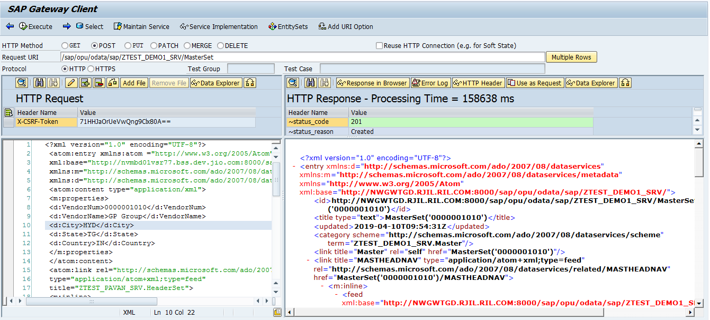

**GET_EXPANDED_ENTITY Method:**

This method can be used for a read operation for an expanded entity / entry. The read operation is similar to GET_ENTITY which has an additional expand reference to retrieve data in an in lined/deep format.

The expand query option is passed via the object reference IO_EXPAND. It can be used to validate whether the current expand expression matches a given expand expression. If the expand expression matches the data reference, then ER_ENTITY can directly be filled by the implementation with data in a deep format. All navigation properties of an entity type including. Its sub paths are valid expand expressions to check and to handle by the application. All expand paths (separated by comma) which are handled by the implementation have to be passed back to the framework via the parameter ET_EXPANDED_TECH_CLAUSES.

**Parameters Used in GET_EXPANDED_ENTITY:**

**IV_ENTITY_NAME:** Name of the entity type which is requested. If there is a navigation it means that it represents the end/target of the navigation path. Type string

**IT_KEY_TAB:** This is an Input Parameter Which Contains Two Fields Name and Value. it is Used to Represents the keys of the First Segment.

Type /IWBEP/T_MGW_NAME_VALUE_PAIR

**ET_EXPANDED_TECH_CLAUSES:** This parameter is filled by the application and contains all expanded paths which have been handled by the application itself. This list of expand clauses is based on the technical (internal) navigation property names, not the external names

**GET_EXPANDED_ENTITY Code:**

  METHOD /iwbep/if_mgw_appl_srv_runtime~get_expanded_entity.  
    TYPES: BEGIN OF ty_heditm.  
            INCLUDE TYPE zcl_ztest_pavan_mpc=>ts_header.  
    TYPES: headitemnav TYPE STANDARD TABLE OF zcl_ztest_pavan_mpc=>ts_item  
                                                WITH DEFAULT KEY,  
           END OF ty_heditm.  
  
    TYPES: BEGIN OF ty_mashed.  
            INCLUDE TYPE zcl_ztest_pavan_mpc=>ts_master.  
    TYPES: mastheadnav TYPE STANDARD TABLE OF ty_heditm WITH DEFAULT KEY,  
           END OF ty_mashed.  
  
    CONSTANTS: lc_expanded_tech_clauses TYPE string  
                                       VALUE 'MASTHEADNAV/HEADITEMNAV'.  
  
    DATA: wa_mashed    TYPE ty_mashed,  
          wa_heditm    TYPE ty_heditm,  
          wa_itm       TYPE zcl_ztest_pavan_mpc=>ts_item,  
          wa_lfa1      TYPE zlfa1_master,  
          wa_ekko      TYPE zekko_header,  
          it_ekko      TYPE STANDARD TABLE OF zekko_header,  
          wa_ekpo      TYPE zekpo_item,  
          it_ekpo      TYPE STANDARD TABLE OF zekpo_item,  
          wa_key_tab   LIKE LINE OF it_key_tab,  
          lv_lifnr     TYPE zlfa1_master-lifnr,  
          lo_container TYPE REF TO /iwbep/if_message_container,  
          ls_return    TYPE bapiret2.  
  
    READ TABLE it_key_tab INTO wa_key_tab WITH KEY  
                                          name = 'VendorNum'.  
    IF sy-subrc = 0.  
      lv_lifnr = wa_key_tab-value.  
      UNPACK lv_lifnr TO lv_lifnr.  
    ENDIF.  
  
    SELECT SINGLE * FROM zlfa1_master INTO wa_lfa1 WHERE lifnr = lv_lifnr.  
    IF sy-subrc = 0 .  
      SELECT * FROM zekko_header INTO TABLE it_ekko WHERE lifnr = lv_lifnr.  
      IF it_ekko[] IS NOT INITIAL.  
        SELECT * FROM zekpo_item INTO TABLE it_ekpo FOR ALL ENTRIES  
           IN it_ekko WHERE ebeln = it_ekko-ebeln AND lifnr = it_ekko-lifnr.  
      ELSE.  
        ls_return-type = 'E'.  
        ls_return-message = 'No Data Found'.  
  
        lo_container = me->mo_context->get_message_container( ).  
  
        CALL METHOD lo_container->add_message  
          EXPORTING  
            iv_msg_type   = ls_return-type  
            iv_msg_id     = ls_return-id  
            iv_msg_number = ls_return-number  
            iv_msg_text   = ls_return-message.  
  
        RAISE EXCEPTION TYPE /iwbep/cx_mgw_busi_exception  
          EXPORTING  
            message_container = lo_container.  
        RETURN.  
      ENDIF.  
  
    ELSE.  
      ls_return-type = 'E'.  
      ls_return-message = 'No Data Found'.  
  
      lo_container = me->mo_context->get_message_container( ).  
  
      CALL METHOD lo_container->add_message  
        EXPORTING  
          iv_msg_type   = ls_return-type  
          iv_msg_id     = ls_return-id  
          iv_msg_number = ls_return-number  
          iv_msg_text   = ls_return-message.  
  
      RAISE EXCEPTION TYPE /iwbep/cx_mgw_busi_exception  
        EXPORTING  
          message_container = lo_container.  
      RETURN.  
    ENDIF.  
  
    wa_mashed-lifnr = wa_lfa1-lifnr.  
    wa_mashed-name1 = wa_lfa1-name1.  
    wa_mashed-ort01 = wa_lfa1-ort01.  
    wa_mashed-regio = wa_lfa1-regio.  
    wa_mashed-land1 = wa_lfa1-land1.  
  
    LOOP AT it_ekko INTO wa_ekko WHERE lifnr = wa_lfa1-lifnr.  
      wa_heditm-ebeln = wa_ekko-ebeln.  
      wa_heditm-lifnr = wa_ekko-lifnr.  
      wa_heditm-bukrs = wa_ekko-bukrs.  
      wa_heditm-butxt = wa_ekko-butxt.  
      wa_heditm-aedat = wa_ekko-aedat.  
      wa_heditm-ernam = wa_ekko-ernam.  
  
      LOOP AT it_ekpo INTO wa_ekpo WHERE ebeln = wa_ekko-ebeln.  
        wa_itm-ebeln = wa_ekpo-ebeln.  
        wa_itm-ebelp = wa_ekpo-ebelp.  
        wa_itm-matnr = wa_ekpo-matnr.  
        wa_itm-maktx = wa_ekpo-maktx.  
        wa_itm-bukrs = wa_ekpo-bukrs.  
        wa_itm-werks = wa_ekpo-werks.  
        APPEND wa_itm TO wa_heditm-headitemnav.  
        CLEAR: wa_itm, wa_ekpo.  
      ENDLOOP.  
  
      APPEND wa_heditm TO wa_mashed-mastheadnav.  
      CLEAR: wa_heditm, wa_ekko.  
    ENDLOOP.  
  
    copy_data_to_ref( EXPORTING is_data = wa_mashed  
                      CHANGING cr_data = er_entity ).  
  
    INSERT lc_expanded_tech_clauses INTO TABLE et_expanded_tech_clauses.  
  
  ENDMETHOD.

Save, Check and Active the Method.

Open the ‘ACTIVATE AND MAINTAIN SERVICES’ in New Session

-> Select our Service

-> Click on Load Metadata

-> Click on Gateway Client

-> Click on EntitySets and Select Entityset Name

-> Select the HTTP Method ‘Get’

**URL:**/sap/opu/odata/sap/ZTEST_PAVAN_SRV/MasterSet('0000001005')/?$expand= MASTHEADNAV/HEADITEMNAV

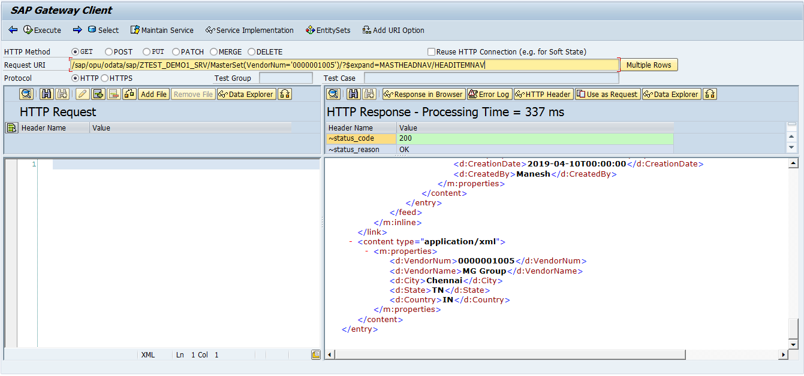

**GET_EXPANDED_ENTITYSET Method :**

The (query) operation similar to GET_ENTITYSET which has an additional expand reference to retrieve data in an inlined/deep format. Note that the SAP NetWeaver Gateway framework can completely handle expand requests in a generic way. In case of performance-critical scenarios or if you experience a bad response time it is highly recommended to handle complex full/subsets of the expand request by specific implementations. Therefore it is required to redefine GET_EXPANDED_ENTITYSET. If you redefine GET_EXPANDED_ENTITYSET and the given expand expression cannot be handled by the application logic it is required to delegate to the super method or to the implementation of the super class.

The expand query option is passed via the object reference IO_EXPAND. It can be used to validate whether the current expand expression matches a given expand expression. If the expand expression matches the data reference, then ER_ENTITY can directly be filled by the implementation with data in a deep format. All navigation properties of an entity type including. its sub paths are valid expand expressions to check and to handle by the application. All expand paths (separated by comma) which are handled by the implementation have to be passed back to the framework via the parameter ET_EXPANDED_TECH_CLAUSES.

**Parameters Used in GET_EXPANDED_ENTITYSET:**

**ER_ENTITYSET:** The returned reference to the application specific table which contains the data. In difference to the GET_ENTITYSET method the ER_ENTITYSET reference is already pre-filled with a data reference of a deep structure component of the final expanded result feed. The ER_ENTITYSET can then be filled by the application specific implementation.

**IO_TECH_REQUEST_CONTEXT:** This parameter of type /IWBEP/IF_MGW_REQ_ENTITY contains all request information and represents the requested entities in a technical format meaning with their technical naming.

**IO_EXPAND:** Represents the expand expression for the navigation properties of the nested entry/feed which need to be inlined.

**ET_EXPANDED_CLAUSES:** This parameter is obsolete, use ET_EXPANDED_TECH_CLAUSES instead.

**ET_EXPANDED_TECH_CLAUSES:** This parameter is filled by the application and contains all expanded paths which have been handled by the application itself. This list of expand clauses is based on the technical (internal) navigation property names, not the external names

**GET_EXPANDED_ENTITYSET Code:**

  method /IWBEP/IF_MGW_APPL_SRV_RUNTIME~GET_EXPANDED_ENTITYSET.  
TYPES: BEGIN OF ty_heditm.  
            INCLUDE TYPE zcl_ztest_pavan_mpc=>ts_header.  
    TYPES: headitemnav TYPE STANDARD TABLE OF zcl_ztest_pavan_mpc=>ts_item                                               WITH DEFAULT KEY,  
           END OF ty_heditm.  
  
  
    TYPES: BEGIN OF ty_mashed.  
            INCLUDE TYPE zcl_ztest_pavan_mpc=>ts_master.  
    TYPES: mastheadnav TYPE STANDARD TABLE OF ty_heditm WITH DEFAULT KEY,  
           END OF ty_mashed.  
  
    CONSTANTS: lc_expanded_tech_clauses TYPE string VALUE 'MASTHEADNAV/HEADITEMNAV'.  
  
    DATA: wa_mashed       TYPE ty_mashed,  
          it_mashed       TYPE TABLE OF ty_mashed,  
          wa_heditm       TYPE ty_heditm,  
          wa_itm          TYPE zcl_ztest_pavan_mpc=>ts_item,  
          wa_lfa1         TYPE zlfa1_master,  
          it_lfa1         TYPE STANDARD TABLE OF zlfa1_master,  
          wa_ekko         TYPE zekko_header,  
          it_ekko         TYPE STANDARD TABLE OF zekko_header,  
          wa_ekpo         TYPE zekpo_item,  
          it_ekpo         TYPE STANDARD TABLE OF zekpo_item,  
          ls_filter       TYPE /iwbep/s_mgw_select_option,  
          ls_filter_range TYPE /iwbep/s_cod_select_option,  
          lr_lifnr        TYPE RANGE OF lifnr,  
          ls_lifnr        LIKE LINE OF lr_lifnr,  
          lo_container    TYPE REF TO /iwbep/if_message_container,  
          ls_return       TYPE bapiret2..  
  
    LOOP AT it_filter_select_options INTO ls_filter.  
  
      CASE ls_filter-property.  
        WHEN 'VendorNum'.  
          LOOP AT ls_filter-select_options INTO ls_filter_range.  
            ls_lifnr-low = ls_filter_range-low.  
            ls_lifnr-option = 'EQ'.  
            ls_lifnr-sign = 'I'.  
            APPEND ls_lifnr TO lr_lifnr.  
            CLEAR: ls_lifnr.  
          ENDLOOP.  
      ENDCASE.  
    ENDLOOP.  
  
  
    SELECT * FROM zlfa1_master INTO TABLE it_lfa1 WHERE lifnr IN lr_lifnr.  
    IF sy-subrc = 0 .  
      SELECT * FROM zekko_header INTO TABLE it_ekko FOR ALL ENTRIES IN it_lfa1 WHERE lifnr = it_lfa1-lifnr.  
      IF it_ekko[] IS NOT INITIAL.  
        SELECT * FROM zekpo_item INTO TABLE it_ekpo FOR ALL ENTRIES IN it_ekko WHERE ebeln = it_ekko-ebeln.  
      ELSE.  
        ls_return-type = 'E'.  
        ls_return-message = 'No Data Found'.  
  
        lo_container = me->mo_context->get_message_container( ).  
  
        CALL METHOD lo_container->add_message  
          EXPORTING  
            iv_msg_type   = ls_return-type  
            iv_msg_id     = ls_return-id  
            iv_msg_number = ls_return-number  
            iv_msg_text   = ls_return-message.  
  
        RAISE EXCEPTION TYPE /iwbep/cx_mgw_busi_exception  
          EXPORTING  
            message_container = lo_container.  
        RETURN.  
      ENDIF.  
    ELSE.  
      ls_return-type = 'E'.  
      ls_return-message = 'No Data Found'.  
  
      lo_container = me->mo_context->get_message_container( ).  
  
      CALL METHOD lo_container->add_message  
        EXPORTING  
          iv_msg_type   = ls_return-type  
          iv_msg_id     = ls_return-id  
          iv_msg_number = ls_return-number  
          iv_msg_text   = ls_return-message.  
  
      RAISE EXCEPTION TYPE /iwbep/cx_mgw_busi_exception  
        EXPORTING  
          message_container = lo_container.  
      RETURN.  
    ENDIF.  
    LOOP AT it_lfa1 INTO wa_lfa1.  
      wa_mashed-lifnr = wa_lfa1-lifnr.  
      wa_mashed-name1 = wa_lfa1-name1.  
      wa_mashed-ort01 = wa_lfa1-ort01.  
      wa_mashed-regio = wa_lfa1-regio.  
      wa_mashed-land1 = wa_lfa1-land1.  
  
      LOOP AT it_ekko INTO wa_ekko WHERE lifnr = wa_lfa1-lifnr.  
        wa_heditm-ebeln = wa_ekko-ebeln.  
        wa_heditm-lifnr = wa_ekko-lifnr.  
        wa_heditm-bukrs = wa_ekko-bukrs.  
        wa_heditm-butxt = wa_ekko-butxt.  
        wa_heditm-aedat = wa_ekko-aedat.  
        wa_heditm-ernam = wa_ekko-ernam.  
  
        LOOP AT it_ekpo INTO wa_ekpo WHERE ebeln = wa_ekko-ebeln.  
          wa_itm-ebeln = wa_ekpo-ebeln.  
          wa_itm-ebelp = wa_ekpo-ebelp.  
          wa_itm-matnr = wa_ekpo-matnr.  
          wa_itm-maktx = wa_ekpo-maktx.  
          wa_itm-bukrs = wa_ekpo-bukrs.  
          wa_itm-werks = wa_ekpo-werks.  
          APPEND wa_itm TO wa_heditm-headitemnav.  
          CLEAR: wa_itm, wa_ekpo.  
        ENDLOOP.  
        APPEND wa_heditm TO wa_mashed-mastheadnav.  
        CLEAR: wa_heditm, wa_ekko.  
      ENDLOOP.  
      APPEND wa_mashed TO it_mashed.  
      CLEAR: wa_mashed, wa_lfa1.  
    ENDLOOP.  
  
    copy_data_to_ref( EXPORTING is_data = it_mashed  
                      CHANGING cr_data = er_entityset ).  
  
    INSERT lc_expanded_tech_clauses INTO TABLE et_expanded_tech_clauses.  
  
  endmethod. Save, Check and Active the Method.

Open the ‘ACTIVATE AND MAINTAIN SERVICES’ in New Session

-> Select our Service

-> Click on Load Metadata

-> Click on Gateway Client

-> Click on EntitySets and Select Entityset Name

-> Select the HTTP Method ‘Get’

**URL:**/sap/opu/odata/sap/ZTEST_DEMO1_SRV/MasterSet?$filter=VendorNum eq '0000001005' or VendorNum eq '0000001010'&$expand=MASTHEADNAV/HEADITEMNAV

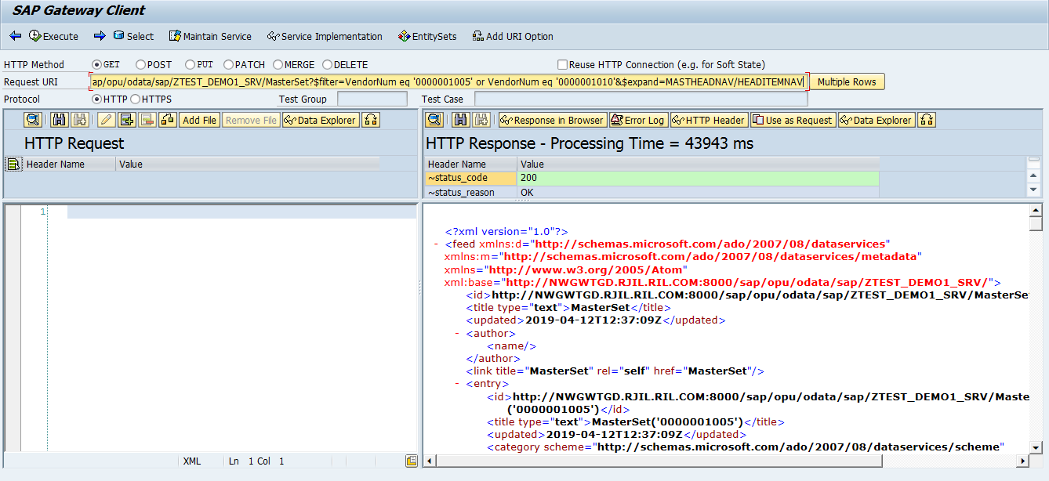

**Create Stream(File Upload) and Get Stream(File Download)**

**UserPhoto Entity Type:-**

Expand The Project ‘ZTEST_PAVAN’.

Select The Data Model and Right Click on it -> IMPORT -> DDIC Structure.

Provide Entity Name: ‘UserPhoto’, ABAP Structure Name: ‘ZUSERPHOTO’ Click on Next.

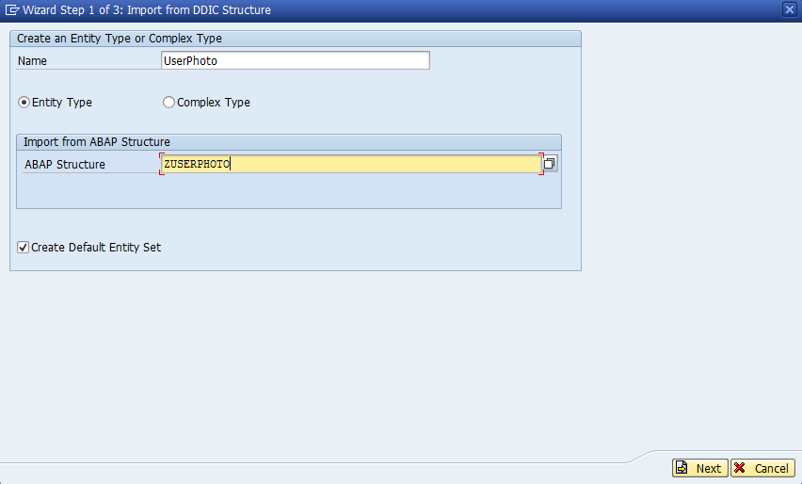

Select our Required Fields and Click on Next.

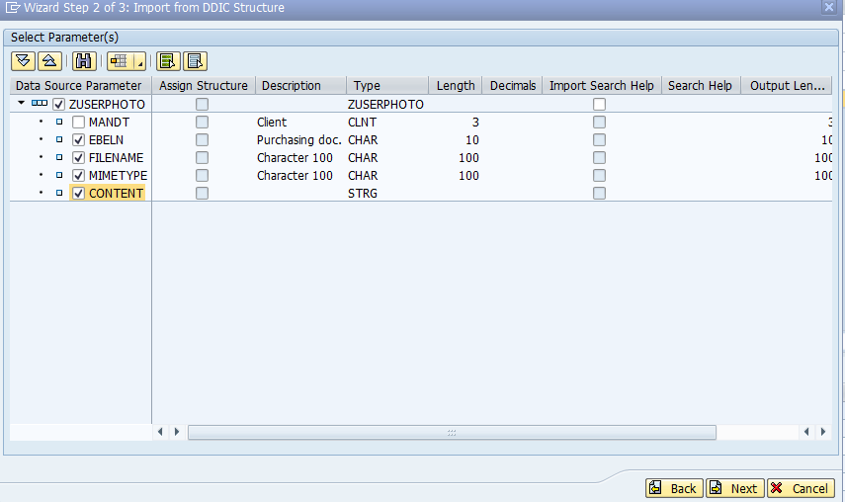

Select the check Box Is Key and Click on Finish.

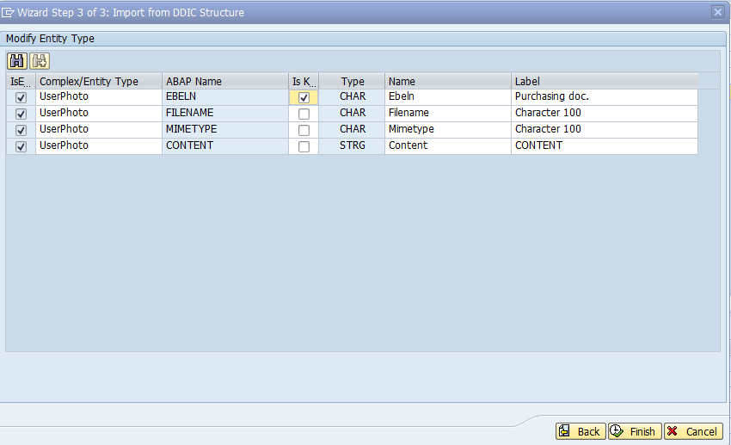

* Expand the Data Model->Expand the Entity Types->double click on Entity Type select the check box ‘Media’

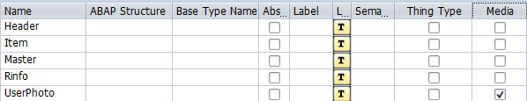

Save Project, Click on Check Project Consistency and Click on Generate Runtime Objects.

To Implement Methods Expand the Runtime Artifacts.

Select the ‘ZCL_ZTEST_PAVAN_MPC_EXT’ -> Right Click on it -> Go to Abap Work Bench

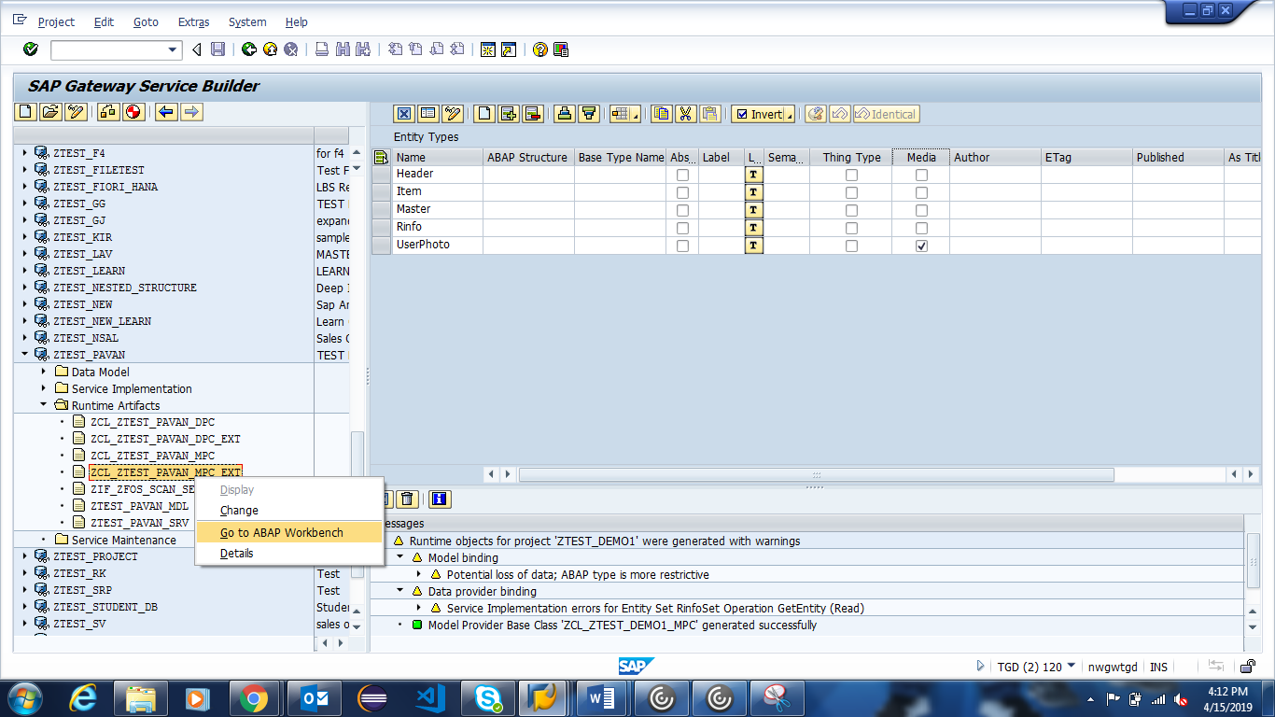

Select the ‘Define’ Method -> Click on Edit Mode -> Click on Redefine

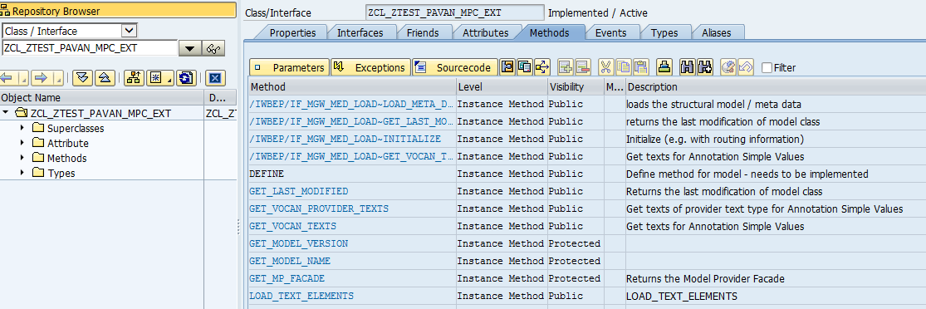

  method DEFINE.  
    super->DEFINE( ).  
  
   data: lo_entity TYPE ref to /IWBEP/IF_MGW_ODATA_ENTITY_TYP,  
         lo_property TYPE REF TO /IWBEP/IF_MGW_ODATA_PROPERTY.  
  
    lo_entity = model->GET_ENTITY_TYPE( IV_ENTITY_NAME = 'UserPhoto').  
    if LO_ENTITY is BOUND.  
    lo_property = LO_ENTITY->GET_PROPERTY( IV_PROPERTY_NAME = 'Mimetype').  
    LO_PROPERTY->SET_AS_CONTENT_TYPE( ).  
    ENDIF.  
  endmethod.

Save, Check and Active the Method.

**CREATE_STREAM Method:**

**Parameters Used in CREATE_STREAM:**

**IS_MEDIA_RESOURCE:** Content type and content value. For example, Content type = ‘image/jpeg’ and content value ’sdfghjk’ Type TY_S_MEDIA_RESOURCE

**IV_SLUG:** Slug is a special HTTP header parameter to pass additional value to Create Stream. For example, slug

**CREATE_STREAM Code:**

  METHOD /iwbep/if_mgw_appl_srv_runtime~create_stream.  
    DATA : wa_key_tab   TYPE /iwbep/s_mgw_name_value_pair,  
           wa_image     TYPE zuserphoto,  
           lv_ebeln     TYPE zuserphoto-ebeln,  
           wa_media     TYPE ty_s_media_resource,  
           json         TYPE string,  
           ls_return    TYPE bapiret2,  
           lt_return    TYPE bapiret2_t,  
           lv_slug      TYPE string,  
           lw_lheader   TYPE ihttpnvp,  
           lo_message   TYPE REF TO zcl_fiori_format_message_json,  
           lo_container TYPE REF TO /iwbep/if_message_container.  
  
    lv_ebeln = iv_slug.  
  
    CALL FUNCTION 'CONVERSION_EXIT_ALPHA_INPUT'  
      EXPORTING  
        input  = lv_ebeln  
      IMPORTING  
        output = lv_ebeln.  
  
    wa_image-ebeln = lv_ebeln.  
    wa_image-content = is_media_resource-value.  
    wa_image-mimetype = is_media_resource-mime_type.  
    wa_image-filename = iv_slug.  
  
    wa_media = is_media_resource.  
  
  
    INSERT zuserphoto FROM wa_image.  
    IF sy-subrc EQ 0.  
      COMMIT WORK.  
  
      ls_return-type = 'S'.  
      ls_return-message = 'Data Updated Successfully'.  
      APPEND ls_return TO lt_return.  
  
      CREATE OBJECT lo_message.  
      CALL METHOD lo_message->message_format  
        EXPORTING  
          im_returnmsg = lt_return  
        IMPORTING  
          ex_json      = json.  
  
  
      lw_lheader-name = 'sap-message'.  
      lw_lheader-value = json.  
      set_header( is_header = lw_lheader ).  
  
    ELSE.  
      ls_return-type = 'E'.  
      ls_return-message = 'Error in updating data '.  
  
      lo_container = me->mo_context->get_message_container( ).  
  
      CALL METHOD lo_container->add_message  
        EXPORTING  
          iv_msg_type   = ls_return-type  
          iv_msg_id     = ls_return-id  
          iv_msg_number = ls_return-number  
          iv_msg_text   = ls_return-message.  
  
      RAISE EXCEPTION TYPE /iwbep/cx_mgw_busi_exception  
        EXPORTING  
          message_container = lo_container.  
    ENDIF.  
  
    copy_data_to_ref( EXPORTING is_data = wa_image  
              CHANGING cr_data = er_entity ).  
  
  ENDMETHOD.

Save, Check and Active the Method.

Open the ‘ACTIVATE AND MAINTAIN SERVICES’ in New Session

-> Select our Service

-> Click on Load Metadata

-> Click on Gateway Client

-> Click on EntitySets and Select Entityset Name

-> Select the HTTP Method ‘Post’

**URL:** /sap/opu/odata/sap/ZTEST_PAVAN_SRV/UserPhotoSet

Click on ‘Add File’

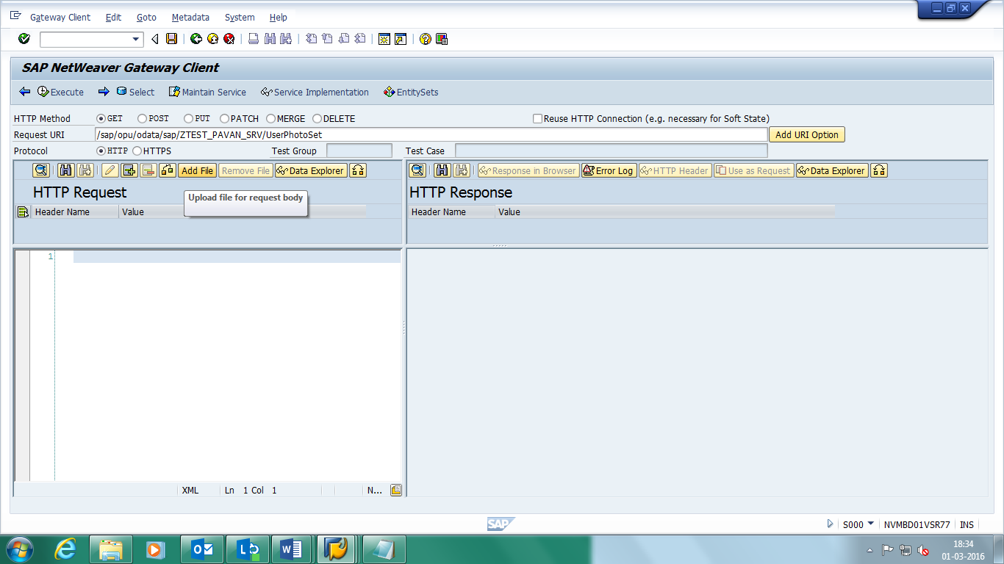

Click on ‘Add Header’->Provide Header Name = ‘slug’ and Header Value = ‘1111111121’(Document Number)

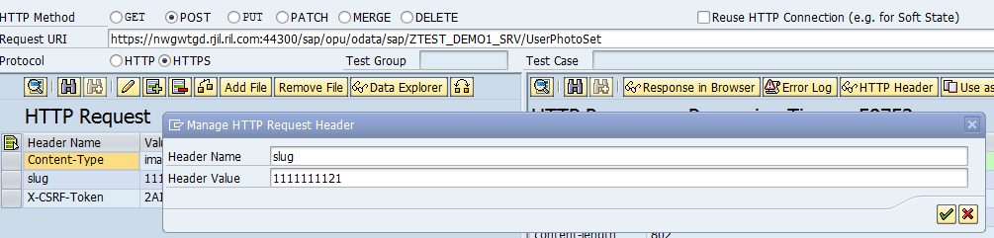

Click on Execute.

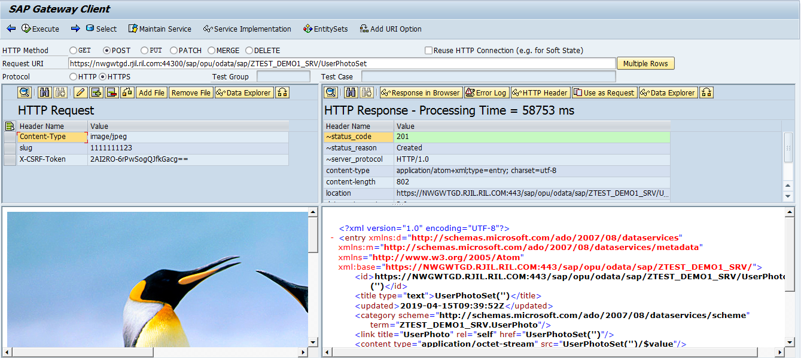

**GET_STREAM Method:**

**Parameters Used in GET_STREAM:**

**ER_STREAM:** The returned reference to the media resource structure which contains the binary data and the MIME type of a media resource.

**IT_KEY_TAB:** Represents the keys or NavPropCollection of the first segment. Type /IWBEP/T_MGW_NAME_VALUE_PAIR

**IV_ENTITY_NAME:** Name of the entity type which is requested. If there is a navigation it means that it represents the end/target of the navigation path. Type string

**GET_STREAM Code:**

 method /IWBEP/IF_MGW_APPL_SRV_RUNTIME~GET_STREAM.  
  
    DATA : wa_key_tab  TYPE /iwbep/s_mgw_name_value_pair,  
           wa_image    TYPE zuserphoto,  
           lv_ebeln    TYPE ebeln,  
           lw_header   TYPE ihttpnvp,  
           lw_filename TYPE string,  
           wa_media    TYPE ty_s_media_resource,  
          ls_return    TYPE bapiret2,  
          lo_container TYPE REF TO /iwbep/if_message_container.  
  
  
    CASE iv_entity_name.  
      WHEN 'UserPhoto'.  
  
        READ TABLE it_key_tab INTO wa_key_tab WITH KEY name = 'Ebeln'.  
        IF sy-subrc EQ 0.  
          lv_ebeln = wa_key_tab-value.  
        ENDIF.  
  
        CALL FUNCTION 'CONVERSION_EXIT_ALPHA_INPUT'  
          EXPORTING  
            input  = lv_ebeln  
          IMPORTING  
            output = lv_ebeln.  
  
        SELECT SINGLE * FROM zuserphoto INTO wa_image WHERE ebeln = lv_ebeln.  
        IF wa_image IS NOT INITIAL.  
  
          wa_media-value = wa_image-content.  
          wa_media-mime_type = wa_image-mimetype.  
  
          lw_filename = lv_ebeln.  
          CONCATENATE lw_filename '.PDF' into lw_filename.  
  
          lw_filename = escape( val    = lw_filename  
                                format = cl_abap_format=>e_url ).  
          lw_header-name  = 'Content-Disposition'(003).  
          lw_header-value = |inline; filename=*"{ lw_filename }"|.*  
          set_header( is_header = lw_header ).  
  
          copy_data_to_ref( EXPORTING is_data = wa_media  
                                      CHANGING cr_data = er_stream ).  
          else.  
  
          ls_return-type = 'E'.  
          ls_return-message = 'No Data Found'.  
  
          lo_container = me->mo_context->get_message_container( ).  
  
          CALL METHOD lo_container->add_message  
            EXPORTING  
              iv_msg_type   = ls_return-type  
              iv_msg_id     = ls_return-id  
              iv_msg_number = ls_return-number  
              iv_msg_text   = ls_return-message.  
  
          RAISE EXCEPTION TYPE /iwbep/cx_mgw_busi_exception  
            EXPORTING  
              message_container = lo_container.  
  
  
        ENDIF.  
    ENDCASE.

endmethod.

Save, Check and Active the Method.

Open the ‘ACTIVATE AND MAINTAIN SERVICES’ in New Session

-> Select our Service

-> Click on Load Metadata

-> Click on Gateway Client

-> Click on EntitySets and Select Entityset Name

-> Select the HTTP Method ‘Get’

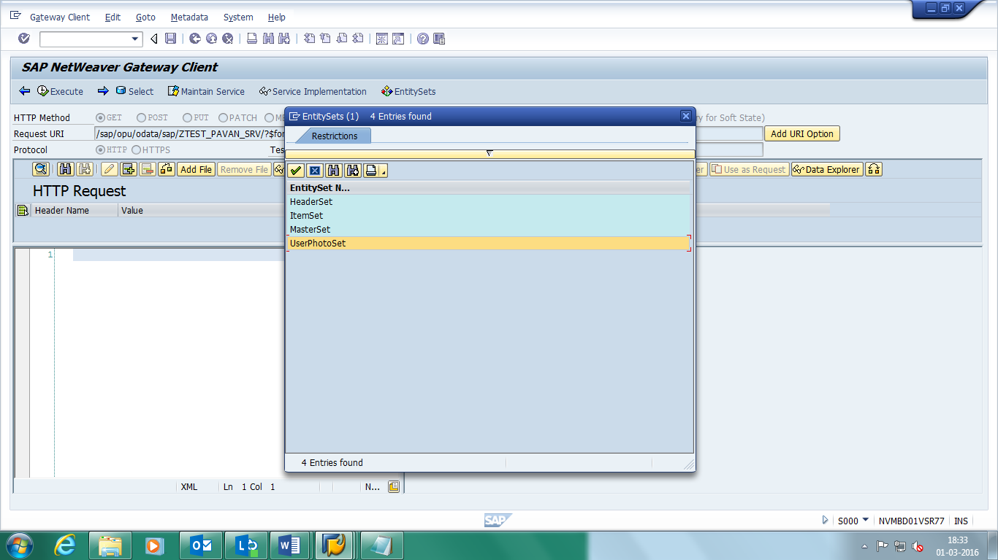

**URL:** /sap/opu/odata/sap/ZTEST_PAVAN_SRV/UserPhotoSet(Eblen='1111111121')/$value

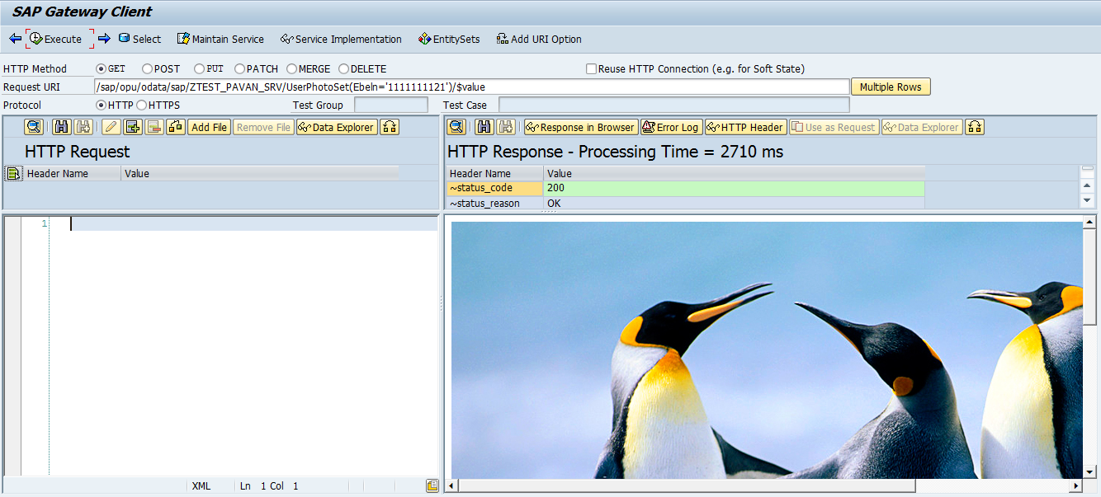

**Multi Origin Composition:**

Multiple Origin Composition (MOC) is a new and an emerging concept in SAP that describes the ability to collect data from different backend systems, integrate them into a single service and update diverse backend systems, while using the same user. we need to understand few constraints (limitations) for implementing MOC, which are as follows:

1. OData Project name and service name must be same.
2. OData EntitySet and Properties name must be same.
3. Login user must available in backend systems.

Before register our Odata service we need to redefine and write below code in each and every GetEntitySet method which are implemented in our Odata project.

  DATA lv_saporigin TYPE c LENGTH 11.

        WHEN 'SAP__ORIGIN'.  
          lv_saporigin = ls_filter_range-low.



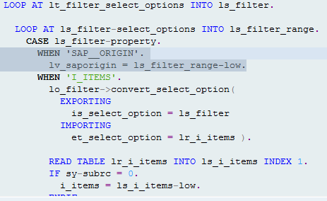

After register the service name we need add System Aliases in ‘/iwfnd/maint_service’ Tcode.

-> Select our Service-> Click on Load Metadata

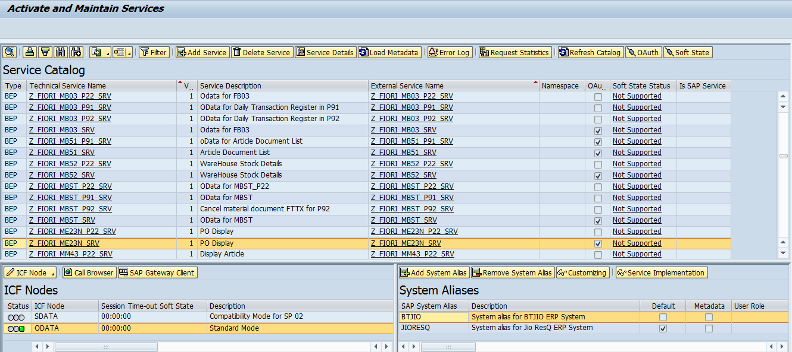

Click on Add system Aliases -> Click on Enter

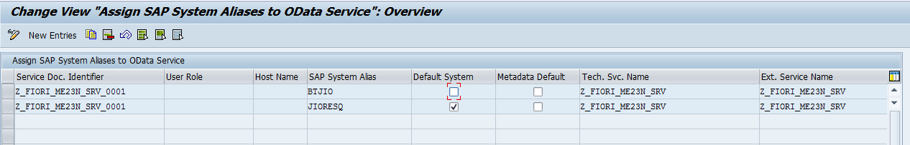

Click on New Entries -> Provide require details.

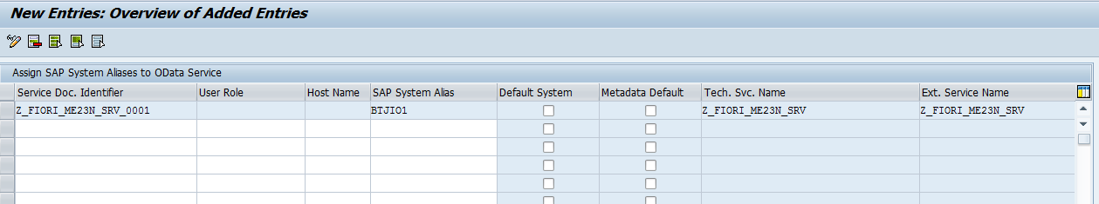

Click on Save -> click on Back

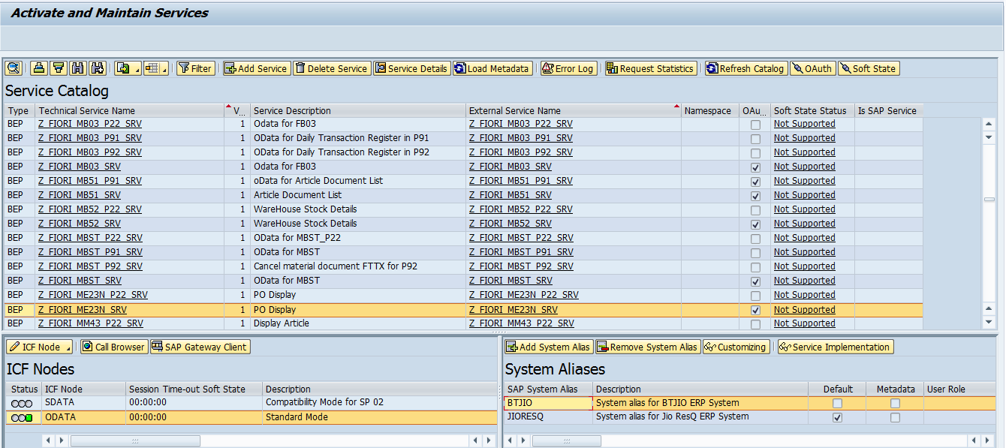

Click on Sap Gateway Client.

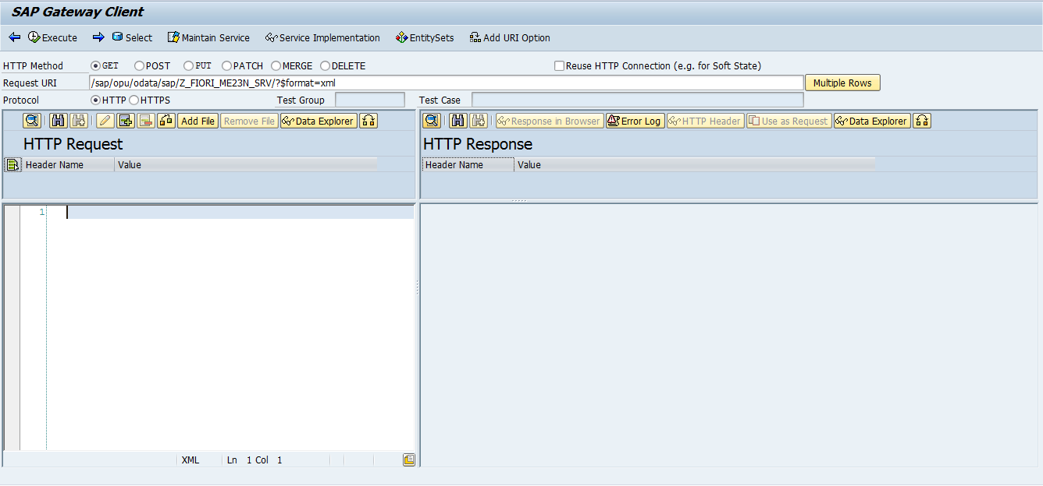

URL’S:

GetEntitySet URL’s:

URL for fetching data from two different Servers:

MaterialListSet:

/sap/opu/odata/sap/Z_FIORI_ME23N_SRV;mo/MaterialListSet?$filter=(SAP__Origin eq 'BTJIO' or SAP__Origin eq 'JIORESQ') and Article eq '400004351' and ArticleIndicator eq 'X' and ArtDescrIndicator eq '' and Site eq '8737' and ArticleDescr eq ''

URL for fetching data from single Server:

MaterialListSet:

/sap/opu/odata/sap/Z_FIORI_ME23N_SRV;mo/MaterialListSet?$filter= SAP__Origin eq 'JIORESQ' and Article eq '400004351' and ArticleIndicator eq 'X' and ArtDescrIndicator eq '' and Site eq '8737' and ArticleDescr eq ''

Note : in Multi Origin concept we can fetch the data form one backend system by using GetEntity method.

GetEntity URL’s:

POHeaderSet:

/sap/opu/odata/sap/Z_FIORI_ME23N_SRV;mo/POHeaderSet(SAP__Origin='JIORESQ',PurchaseOrderNum='6000009506')

Note: after implementing multi origin concept we have configure our service in TGD server by using SPRO tcode.

Execute SPRO tcode -> Click on SAP Reference IMG.

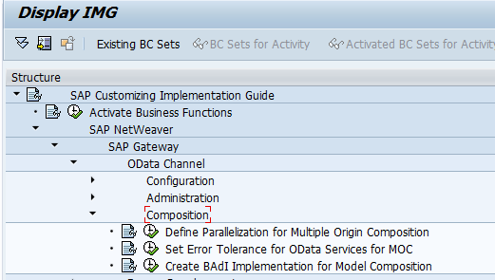

Execute Set Error Tolerance for OData Service for MOC

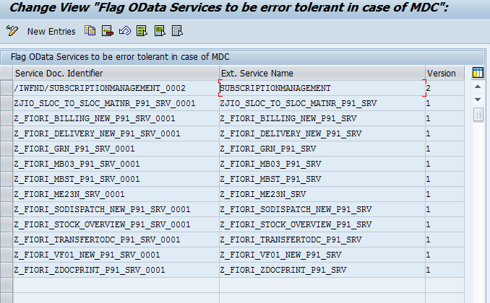

Click on New Entries.

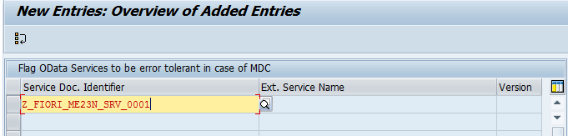

Click on Save.

**Batch Operations:**

OData Batch requests allow the grouping of multiple operations into a single HTTP request payload. Batch Requests are submitted as a single HTTP POST request to the batch endpoint of a service.

Execute ‘SEGW’ Tcode

.-> Expand the Project

-> Expand the Runtime Artifacts

-> Redefine below methods.

    1./IWBEP/IF_MGW_APPL_SRV_RUNTIME~CHANGESET_BEGIN.

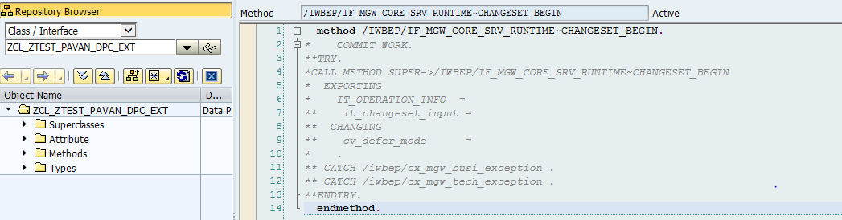

     2./IWBEP/IF_MGW_APPL_SRV_RUNTIME~CHANGESET_END.

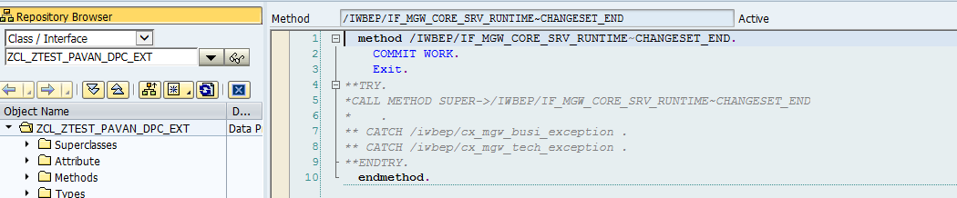

Save, Check and Active the Method.

Open the ‘ACTIVATE AND MAINTAIN SERVICES’ in New Session

-> Select our Service

-> Click on Load Metadata

-> Click on Gateway Client

-> Click on EntitySets and Select Entityset Name

-> Select the HTTP Method ‘Post’

-> Write the Payload in HTTP Request

**URL:** /sap/opu/odata/sap/ZTEST_PAVAN_SRV/$batch

Click on Add Header

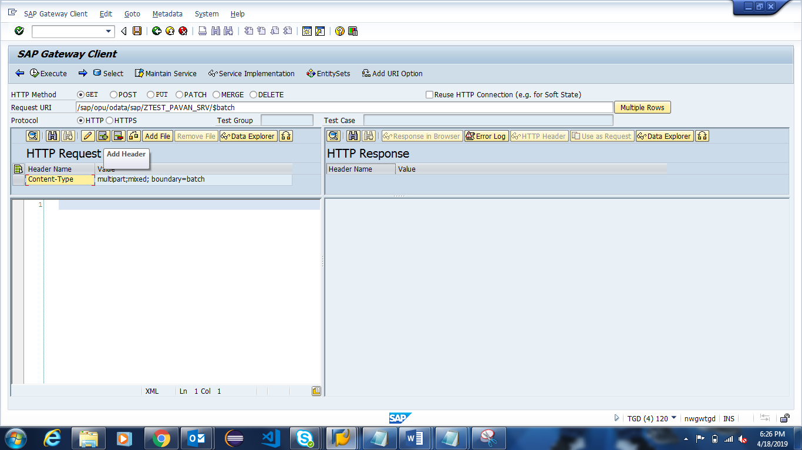

-> provide Header Name: Content-Type and Header Value: multiport/mixed; boundary=batch

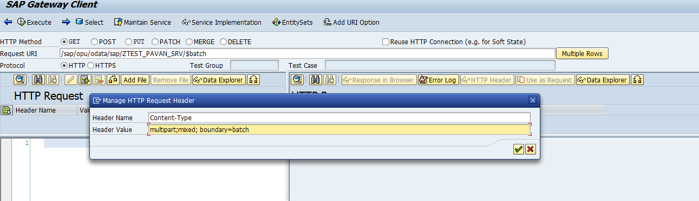

**Payload for Display:**

--batch

Content-Type: application/http

Content-Transfer-Encoding: binary

GET MasterSet?$filter=VendorNum+eq+'0000001006' HTTP/1.1

--batch

Content-Type: application/http

Content-Transfer-Encoding: binary

GET MasterSet?$filter=VendorNum+eq+'0000001006' HTTP/1.1

--batch--

**Payload for Posting:**

--batch

Content-Type: multipart/mixed; boundary=changeset

--changeset

Content-Type: application/http

Content-Transfer-Encoding: binary

POST MasterSet HTTP/1.1

Content-Type: application/atom+xml

Content-Length: 985

<?xml version="1.0" encoding="UTF-8"?>

<atom:entry xmlns:atom ="http://www.w3.org/2005/Atom"

xml:base="http://nvmbd01vsr77.bss.dev.jio.com:8000/sap/opu/odata/sap/ZTEST_PAVAN_SRV/"

xmlns:m="http://schemas.microsoft.com/ado/2007/08/dataservices/metadata"

xmlns:d="http://schemas.microsoft.com/ado/2007/08/dataservices">

<atom:content type="application/xml">

<m:properties>

<d:VendorNum>0000001004</d:VendorNum>

<d:VendorName>MANESH</d:VendorName>

<d:City>MUM</d:City>

<d:State>MP</d:State>

<d:Country>IN</d:Country>

</m:properties>

</atom:content>

</atom:entry>

--changeset

Content-Type: application/http

Content-Transfer-Encoding: binary

POST MasterSet HTTP/1.1

Content-Type: application/atom+xml

Content-Length: 985

<?xml version="1.0" encoding="UTF-8"?>

<atom:entry xmlns:atom ="http://www.w3.org/2005/Atom"

xml:base="http://nvmbd01vsr77.bss.dev.jio.com:8000/sap/opu/odata/sap/ZTEST_PAVAN_SRV/"

xmlns:m="http://schemas.microsoft.com/ado/2007/08/dataservices/metadata"

xmlns:d="http://schemas.microsoft.com/ado/2007/08/dataservices">

<atom:content type="application/xml">

<m:properties>

<d:VendorNum>0000001004</d:VendorNum>

<d:VendorName>MANESH</d:VendorName>

<d:City>MUM</d:City>

<d:State>MP</d:State>

<d:Country>IN</d:Country>

</m:properties>

</atom:content>

</atom:entry>

--changeset--

--batch--

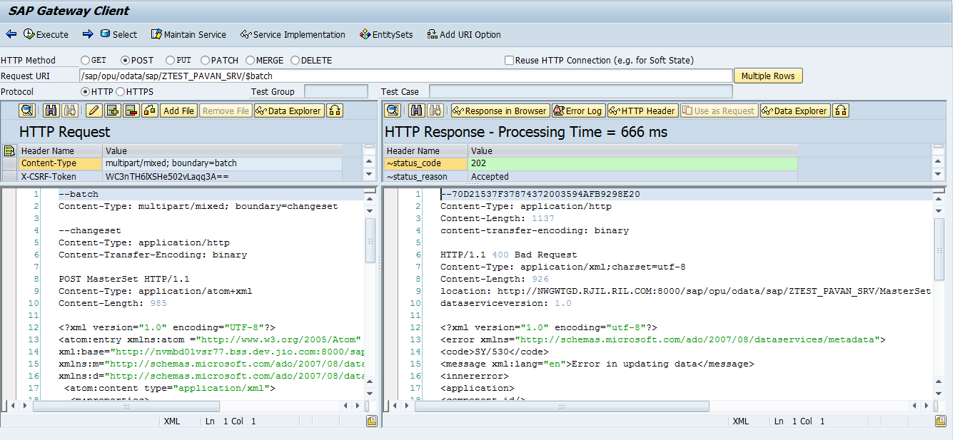

**\*** **THANKING YOU\***